MAULANA ABDUL KALAM AZAD UNIVERSITY OF TECHNOLOGY



A Project submitted in partial fulfilment of

The requirement for the Honours Degree of

Bachelor of Science in Information Technology

SUNDARBAN DEVELOPMENT

Year of Examination: 2024

**Submitted by**

Name- Sukdev Maity Name- Subhadeep Jana

Roll No. - 19260622063 Roll No. - 19260622028

Reg.No-221922410058(2022-23) Reg.No-221922410052(2022-23)

Name- Subodh Giri Name- Subhodeep Golui

Roll No. - 19260622029 Roll No. - 19260622034

Reg.No-221922410056(2022-23) Reg.No-221922410055(2022-23)

Name- Susovan Jana Name- Pranab Samanta

Roll No. – 19260622010 Roll No. - 19260622009

Reg.No-221922410059(2022-23) Reg.No-221922410033(2022-23)

Name- Ranit Pradhan Name- Tanay Jana

Roll No. – 19260622011 Roll No. - 19260622021

Reg.No-221922410035(2022-23) Reg.No-221922410061(2022-23)

Name- Arpan Mondal Name- Utpal Khaluya

Roll No. - 19260622017 Roll No. - 19260622006

Reg.No-221922410008(2022-23) Reg.No-221922410065(2022-23)

Name- Bidyut Bhunia Name- Sujal Khamrui

Roll No. - 19260622002 Roll No. - 19260622033

Reg.No-221922410013(2022-23) Reg.No-221922410057(2022-23)

Name- Sk Mahammad Atif Raja Name- Shibsankar Bag

Roll No. - 19260622053 Roll No. - 19260622059

Reg.No-221922410045(2022-23) Reg.No-221922410044(2022-23)

Name- Dip Ghosh Name- Anirban Guria

Roll No. – 19260622061 Roll No. - 19260622048

Reg.No-221922410018(2022-23) Reg.No-221922410003(2022-23)

Name- Debjyoti Das Name- Nilanjan Bera

Roll No. – 19260622035 Roll No. - 19260622024

Reg.No-221922410014(2022-23) Reg.No-221922410030(2022-23)

Name- Kousik Paik Name- Kiranmoy Chaulia

Roll No. – 19260622032 Roll No. - 19260622031

Reg.No-221922410024(2022-23) Reg.No-221922410023(2022-23)

Name- Swapnil Seth Name- Partha Fadikar

Roll No. - 19260622013 Roll No. - 19260622022

Reg.No-221922410060(2022-23) Reg.No-221922410032(2022-23)

Of

Global Institute of Science and Technology

#### SELF CERTIFICATE

This is to certify that the dissertation / project report entitled ―Sundarban Development ‖ is done by me is an authentic work carried out for the partial fulfilment of the requirement for the award of the BSC(IT) under the guidance of Mr Partha Koley. I also certify that I am aware of the ―BSC(IT) project & project report standard 2024, Maulana Abdul Kalam Azad University of Technology‖ issued by Maulana Abdul Kalam Azad University of Technology and this project report is based on that standard. The matter embodied in this project work has not submitted earlier for award of any degree or diploma to the best of my knowledge and belief.

Name- Sukdev Maity

Roll No. – 19260622063

Reg.No-221922410058(2022-23)

Of

Global Institute of Science and Technology

#### SELF CERTIFICATE

This is to certify that the dissertation / project report entitled ― Sundarban Development ‖ is done by me is an authentic work carried out for the partial fulfilment of the requirement for the award of the BSC(IT) under the guidance of Mr Partha Koley. I also certify that I am aware of the ―BSC(IT) project & project report standard 2024, Maulana Abdul Kalam Azad University of Technology‖ issued by Maulana Abdul Kalam Azad University of Technology and this project report is based on that standard. The matter embodied in this project work has not submitted earlier for award of any degree or diploma to the best of my knowledge and belief.

Name- Subhadeep Jana

Roll No. - 19260622028

Reg.No-221922410052(2022-23)

Of

Global Institute of Science and Technology

#### SELF CERTIFICATE

This is to certify that the dissertation / project report entitled ― Sundarban Development ‖ is done by me is an authentic work carried out for the partial fulfilment of the requirement for the award of the BSC(IT) under the guidance of Mr Partha Koley. I also certify that I am aware of the ―BSC(IT) project & project report standard 2024, Maulana Abdul Kalam Azad University of Technology‖ issued by Maulana Abdul Kalam Azad University of Technology and this project report is based on that standard. The matter embodied in this project work has not submitted earlier for award of any degree or diploma to the best of my knowledge and belief.

Name- Subodh Giri

Roll No. – 19260622029

Reg.No-221922410056(2022-23)

Of

Global Institute of Science and Technology

#### SELF CERTIFICATE

This is to certify that the dissertation / project report entitled ― Sundarban Development ‖ is done by me is an authentic work carried out for the partial fulfilment of the requirement for the award of the BSC(IT) under the guidance of Mr Partha Koley. I also certify that I am aware of the ―BSC(IT) project & project report standard 2024, Maulana Abdul Kalam Azad University of Technology‖ issued by Maulana Abdul Kalam Azad University of Technology and this project report is based on that standard. The matter embodied in this project work has not submitted earlier for award of any degree or diploma to the best of my knowledge and belief.

|  |
| --- |
|  |
|  |  |

C:\Users\SERVER\AppData\Local\Microsoft\Windows\Clipboard\HistoryData\{B95FAD4E-9838-4D61-B335-9311B67E9483}\{9A781DB7-DBE2-4E49-A1E4-0A03E93E2498}\ResourceMap\{D6276FBD-F710-43B3-B229-6FCFB4259A44}

Name- Subhodeep Golui

Roll No. – 19260622034

Reg.No-221922410055(2022-23)

Of

Global Institute of Science and Technology

#### SELF CERTIFICATE

This is to certify that the dissertation / project report entitled ― Sundarban Development ‖ is done by me is an authentic work carried out for the partial fulfilment of the requirement for the award of the BSC(IT) under the guidance of Mr Partha Koley. I also certify that I am aware of the ―BSC(IT) project & project report standard 2024, Maulana Abdul Kalam Azad University of Technology‖ issued by Maulana Abdul Kalam Azad University of Technology and this project report is based on that standard. The matter embodied in this project work has not submitted earlier for award of any degree or diploma to the best of my knowledge and belief.

|  |
| --- |
|  |
|  |  |

C:\Users\SERVER\AppData\Local\Microsoft\Windows\Clipboard\HistoryData\{B95FAD4E-9838-4D61-B335-9311B67E9483}\{9A781DB7-DBE2-4E49-A1E4-0A03E93E2498}\ResourceMap\{D6276FBD-F710-43B3-B229-6FCFB4259A44}

Name- Susovan Jana

Roll No. – 19260622010

Reg.No-221922410059(2022-23)

Of

Global Institute of Science and Technology

#### SELF CERTIFICATE

This is to certify that the dissertation / project report entitled ― Sundarban Development ‖ is done by me is an authentic work carried out for the partial fulfilment of the requirement for the award of the BSC(IT) under the guidance of Mr Partha Koley. I also certify that I am aware of the ―BSC(IT) project & project report standard 2024, Maulana Abdul Kalam Azad University of Technology‖ issued by Maulana Abdul Kalam Azad University of Technology and this project report is based on that standard. The matter embodied in this project work has not submitted earlier for award of any degree or diploma to the best of my knowledge and belief.

|  |
| --- |
|  |
|  |  |

C:\Users\SERVER\AppData\Local\Microsoft\Windows\Clipboard\HistoryData\{B95FAD4E-9838-4D61-B335-9311B67E9483}\{9A781DB7-DBE2-4E49-A1E4-0A03E93E2498}\ResourceMap\{D6276FBD-F710-43B3-B229-6FCFB4259A44}

  Name- Pranab Samanta

Roll No. – 19260622009

Reg.No-221922410033(2022-23)

Of

Global Institute of Science and Technology

#### SELF CERTIFICATE

This is to certify that the dissertation / project report entitled ― Sundarban Development ‖ is done by me is an authentic work carried out for the partial fulfilment of the requirement for the award of the BSC(IT) under the guidance of Mr Partha Koley. I also certify that I am aware of the ―BSC(IT) project & project report standard 2024, Maulana Abdul Kalam Azad University of Technology‖ issued by Maulana Abdul Kalam Azad University of Technology and this project report is based on that standard. The matter embodied in this project work has not submitted earlier for award of any degree or diploma to the best of my knowledge and belief.

|  |
| --- |
|  |
|  |  |

C:\Users\SERVER\AppData\Local\Microsoft\Windows\Clipboard\HistoryData\{B95FAD4E-9838-4D61-B335-9311B67E9483}\{9A781DB7-DBE2-4E49-A1E4-0A03E93E2498}\ResourceMap\{D6276FBD-F710-43B3-B229-6FCFB4259A44}

Name- Ranit Pradhan

Roll No. – 19260622011

Reg.No-221922410035(2022-23)

Of

Global Institute of Science and Technology

#### SELF CERTIFICATE

This is to certify that the dissertation / project report entitled ― Sundarban Development ‖ is done by me is an authentic work carried out for the partial fulfilment of the requirement for the award of the BSC(IT) under the guidance of Mr Partha Koley. I also certify that I am aware of the ―BSC(IT) project & project report standard 2024, Maulana Abdul Kalam Azad University of Technology‖ issued by Maulana Abdul Kalam Azad University of Technology and this project report is based on that standard. The matter embodied in this project work has not submitted earlier for award of any degree or diploma to the best of my knowledge and belief.

|  |
| --- |
|  |
|  |  |

C:\Users\SERVER\AppData\Local\Microsoft\Windows\Clipboard\HistoryData\{B95FAD4E-9838-4D61-B335-9311B67E9483}\{1C3C4DB2-BB7D-46B0-9418-FC410986EAA3}\ResourceMap\{F122CBA1-65F3-45C3-9B65-C2FFC1090D68}

Name – Tanay Jana

Roll No. – 19260622021

Reg.No-221922410061(2022-23)

Of

                              Global Institute of Science and Technology

#### SELF CERTIFICATE

This is to certify that the dissertation / project report entitled ― Sundarban Development ‖ is done by me is an authentic work carried out for the partial fulfilment of the requirement for the award of the BSC(IT) under the guidance of Mr Partha Koley. I also certify that I am aware of the ―BSC(IT) project & project report standard 2024, Maulana Abdul Kalam Azad University of Technology‖ issued by Maulana Abdul Kalam Azad University of Technology and this project report is based on that standard. The matter embodied in this project work has not submitted earlier for award of any degree or diploma to the best of my knowledge and belief.

|  |
| --- |
|  |
|  |  |

C:\Users\SERVER\AppData\Local\Microsoft\Windows\Clipboard\HistoryData\{B95FAD4E-9838-4D61-B335-9311B67E9483}\{1C3C4DB2-BB7D-46B0-9418-FC410986EAA3}\ResourceMap\{F122CBA1-65F3-45C3-9B65-C2FFC1090D68}

Name – Arpan Mandal

Roll No. – 19260622017

Reg.No-221922410008(2022-23)

Of

                              Global Institute of Science and Technology

#### SELF CERTIFICATE

This is to certify that the dissertation / project report entitled ― Sundarban Development ‖ is done by me is an authentic work carried out for the partial fulfilment of the requirement for the award of the BSC(IT) under the guidance of Mr Partha Koley. I also certify that I am aware of the ―BSC(IT) project & project report standard 2024, Maulana Abdul Kalam Azad University of Technology‖ issued by Maulana Abdul Kalam Azad University of Technology and this project report is based on that standard. The matter embodied in this project work has not submitted earlier for award of any degree or diploma to the best of my knowledge and belief.

|  |
| --- |
|  |
|  |  |

C:\Users\SERVER\AppData\Local\Microsoft\Windows\Clipboard\HistoryData\{B95FAD4E-9838-4D61-B335-9311B67E9483}\{1C3C4DB2-BB7D-46B0-9418-FC410986EAA3}\ResourceMap\{F122CBA1-65F3-45C3-9B65-C2FFC1090D68}

Name – Utpal Khaluya

Roll No. – 19260622006

Reg.No-221922410065(2022-23)

Of

                              Global Institute of Science and Technology

#### SELF CERTIFICATE

This is to certify that the dissertation / project report entitled ― Sundarban Development ‖ is done by me is an authentic work carried out for the partial fulfilment of the requirement for the award of the BSC(IT) under the guidance of Mr Partha Koley. I also certify that I am aware of the ―BSC(IT) project & project report standard 2024, Maulana Abdul Kalam Azad University of Technology‖ issued by Maulana Abdul Kalam Azad University of Technology and this project report is based on that standard. The matter embodied in this project work has not submitted earlier for award of any degree or diploma to the best of my knowledge and belief.

|  |
| --- |
|  |
|  |  |

C:\Users\SERVER\AppData\Local\Microsoft\Windows\Clipboard\HistoryData\{B95FAD4E-9838-4D61-B335-9311B67E9483}\{1C3C4DB2-BB7D-46B0-9418-FC410986EAA3}\ResourceMap\{F122CBA1-65F3-45C3-9B65-C2FFC1090D68}

Name – Bidyut Bhunia

Roll No. – 19260622002

Reg.No-221922410013(2022-23)

Of

                              Global Institute of Science and Technology

#### SELF CERTIFICATE

This is to certify that the dissertation / project report entitled ― Sundarban Development ‖ is done by me is an authentic work carried out for the partial fulfilment of the requirement for the award of the BSC(IT) under the guidance of Mr Partha Koley. I also certify that I am aware of the ―BSC(IT) project & project report standard 2024, Maulana Abdul Kalam Azad University of Technology‖ issued by Maulana Abdul Kalam Azad University of Technology and this project report is based on that standard. The matter embodied in this project work has not submitted earlier for award of any degree or diploma to the best of my knowledge and belief.

|  |
| --- |
|  |
|  |  |

C:\Users\SERVER\AppData\Local\Microsoft\Windows\Clipboard\HistoryData\{B95FAD4E-9838-4D61-B335-9311B67E9483}\{1C3C4DB2-BB7D-46B0-9418-FC410986EAA3}\ResourceMap\{F122CBA1-65F3-45C3-9B65-C2FFC1090D68}

Name – Sujal Khamrui

Roll No. – 19260622033

Reg.No-221922410057(2022-23)

Of

                              Global Institute of Science and Technology

#### SELF CERTIFICATE

This is to certify that the dissertation / project report entitled ― Sundarban Development ‖ is done by me is an authentic work carried out for the partial fulfilment of the requirement for the award of the BSC(IT) under the guidance of Mr Partha Koley. I also certify that I am aware of the ―BSC(IT) project & project report standard 2024, Maulana Abdul Kalam Azad University of Technology‖ issued by Maulana Abdul Kalam Azad University of Technology and this project report is based on that standard. The matter embodied in this project work has not submitted earlier for award of any degree or diploma to the best of my knowledge and belief.

|  |
| --- |
|  |
|  |  |

C:\Users\SERVER\AppData\Local\Microsoft\Windows\Clipboard\HistoryData\{B95FAD4E-9838-4D61-B335-9311B67E9483}\{1C3C4DB2-BB7D-46B0-9418-FC410986EAA3}\ResourceMap\{F122CBA1-65F3-45C3-9B65-C2FFC1090D68}

Name – Sk Md.Atif Raja

Roll No. – 19260622053

Reg.No-221922410045(2022-23)

Of

                              Global Institute of Science and Technology

#### SELF CERTIFICATE

This is to certify that the dissertation / project report entitled ― Sundarban Development ‖ is done by me is an authentic work carried out for the partial fulfilment of the requirement for the award of the BSC(IT) under the guidance of Mr Partha Koley. I also certify that I am aware of the ―BSC(IT) project & project report standard 2024, Maulana Abdul Kalam Azad University of Technology‖ issued by Maulana Abdul Kalam Azad University of Technology and this project report is based on that standard. The matter embodied in this project work has not submitted earlier for award of any degree or diploma to the best of my knowledge and belief.

|  |
| --- |
|  |
|  |  |

C:\Users\SERVER\AppData\Local\Microsoft\Windows\Clipboard\HistoryData\{B95FAD4E-9838-4D61-B335-9311B67E9483}\{1C3C4DB2-BB7D-46B0-9418-FC410986EAA3}\ResourceMap\{F122CBA1-65F3-45C3-9B65-C2FFC1090D68}

Name – Sibsankar Bag

Roll No. – 19260622059

Reg.No-221922410044(2022-23)

Of

                              Global Institute of Science and Technology

#### SELF CERTIFICATE

This is to certify that the dissertation / project report entitled ― Sundarban Development ‖ is done by me is an authentic work carried out for the partial fulfilment of the requirement for the award of the BSC(IT) under the guidance of Mr Partha Koley. I also certify that I am aware of the ―BSC(IT) project & project report standard 2024, Maulana Abdul Kalam Azad University of Technology‖ issued by Maulana Abdul Kalam Azad University of Technology and this project report is based on that standard. The matter embodied in this project work has not submitted earlier for award of any degree or diploma to the best of my knowledge and belief.

|  |
| --- |
|  |
|  |  |

C:\Users\SERVER\AppData\Local\Microsoft\Windows\Clipboard\HistoryData\{B95FAD4E-9838-4D61-B335-9311B67E9483}\{1C3C4DB2-BB7D-46B0-9418-FC410986EAA3}\ResourceMap\{F122CBA1-65F3-45C3-9B65-C2FFC1090D68}

Name -Dip Ghosh

Roll No. – 19260622061

Reg.No-221922410018(2022-23)

Of

                              Global Institute of Science and Technology

#### SELF CERTIFICATE

This is to certify that the dissertation / project report entitled ― Sundarban Development ‖ is done by me is an authentic work carried out for the partial fulfilment of the requirement for the award of the BSC(IT) under the guidance of Mr Partha Koley. I also certify that I am aware of the ―BSC(IT) project & project report standard 2024, Maulana Abdul Kalam Azad University of Technology‖ issued by Maulana Abdul Kalam Azad University of Technology and this project report is based on that standard. The matter embodied in this project work has not submitted earlier for award of any degree or diploma to the best of my knowledge and belief.

|  |
| --- |
|  |
|  |  |

C:\Users\SERVER\AppData\Local\Microsoft\Windows\Clipboard\HistoryData\{B95FAD4E-9838-4D61-B335-9311B67E9483}\{1C3C4DB2-BB7D-46B0-9418-FC410986EAA3}\ResourceMap\{F122CBA1-65F3-45C3-9B65-C2FFC1090D68}

Name – Anirban Guria

Roll No. – 19260622048

Reg.No-221922410003(2022-23)

Of

                              Global Institute of Science and Technology

#### SELF CERTIFICATE

This is to certify that the dissertation / project report entitled ― Sundarban Development ‖ is done by me is an authentic work carried out for the partial fulfilment of the requirement for the award of the BSC(IT) under the guidance of Mr Partha Koley. I also certify that I am aware of the ―BSC(IT) project & project report standard 2024, Maulana Abdul Kalam Azad University of Technology‖ issued by Maulana Abdul Kalam Azad University of Technology and this project report is based on that standard. The matter embodied in this project work has not submitted earlier for award of any degree or diploma to the best of my knowledge and belief.

|  |
| --- |
|  |
|  |  |

C:\Users\SERVER\AppData\Local\Microsoft\Windows\Clipboard\HistoryData\{B95FAD4E-9838-4D61-B335-9311B67E9483}\{1C3C4DB2-BB7D-46B0-9418-FC410986EAA3}\ResourceMap\{F122CBA1-65F3-45C3-9B65-C2FFC1090D68}

Name – Debjyoti Das

Roll No. – 19260622035

Reg.No-221922410014(2022-23)

Of

                              Global Institute of Science and Technology

#### SELF CERTIFICATE

This is to certify that the dissertation / project report entitled ― Sundarban Development ‖ is done by me is an authentic work carried out for the partial fulfilment of the requirement for the award of the BSC(IT) under the guidance of Mr Partha Koley. I also certify that I am aware of the ―BSC(IT) project & project report standard 2024, Maulana Abdul Kalam Azad University of Technology‖ issued by Maulana Abdul Kalam Azad University of Technology and this project report is based on that standard. The matter embodied in this project work has not submitted earlier for award of any degree or diploma to the best of my knowledge and belief.

|  |
| --- |
|  |
|  |  |

C:\Users\SERVER\AppData\Local\Microsoft\Windows\Clipboard\HistoryData\{B95FAD4E-9838-4D61-B335-9311B67E9483}\{1C3C4DB2-BB7D-46B0-9418-FC410986EAA3}\ResourceMap\{F122CBA1-65F3-45C3-9B65-C2FFC1090D68}

Name – Nilanjan Bera

Roll No. – 19260622024

Reg.No-221922410030(2022-23)

Of

                              Global Institute of Science and Technology

#### SELF CERTIFICATE

This is to certify that the dissertation / project report entitled ― Sundarban Development ‖ is done by me is an authentic work carried out for the partial fulfilment of the requirement for the award of the BSC(IT) under the guidance of Mr Partha Koley. I also certify that I am aware of the ―BSC(IT) project & project report standard 2024, Maulana Abdul Kalam Azad University of Technology‖ issued by Maulana Abdul Kalam Azad University of Technology and this project report is based on that standard. The matter embodied in this project work has not submitted earlier for award of any degree or diploma to the best of my knowledge and belief.

|  |
| --- |
|  |
|  |  |

C:\Users\SERVER\AppData\Local\Microsoft\Windows\Clipboard\HistoryData\{B95FAD4E-9838-4D61-B335-9311B67E9483}\{1C3C4DB2-BB7D-46B0-9418-FC410986EAA3}\ResourceMap\{F122CBA1-65F3-45C3-9B65-C2FFC1090D68}

Name – Koushik Paik

Roll No. – 19260622032

Reg.No-221922410024(2022-23)

Of

                              Global Institute of Science and Technology

#### SELF CERTIFICATE

This is to certify that the dissertation / project report entitled ― Sundarban Development ‖ is done by me is an authentic work carried out for the partial fulfilment of the requirement for the award of the BSC(IT) under the guidance of Mr Partha Koley. I also certify that I am aware of the ―BSC(IT) project & project report standard 2024, Maulana Abdul Kalam Azad University of Technology‖ issued by Maulana Abdul Kalam Azad University of Technology and this project report is based on that standard. The matter embodied in this project work has not submitted earlier for award of any degree or diploma to the best of my knowledge and belief.

|  |
| --- |
|  |
|  |  |

C:\Users\SERVER\AppData\Local\Microsoft\Windows\Clipboard\HistoryData\{B95FAD4E-9838-4D61-B335-9311B67E9483}\{1C3C4DB2-BB7D-46B0-9418-FC410986EAA3}\ResourceMap\{F122CBA1-65F3-45C3-9B65-C2FFC1090D68}

Name – Kiranmoy Chaulia

Roll No. – 19260622031

Reg.No-221922410023(2022-23)

Of

                              Global Institute of Science and Technology

#### SELF CERTIFICATE

This is to certify that the dissertation / project report entitled ― Sundarban Development ‖ is done by me is an authentic work carried out for the partial fulfilment of the requirement for the award of the BSC(IT) under the guidance of Mr Partha Koley. I also certify that I am aware of the ―BSC(IT) project & project report standard 2024, Maulana Abdul Kalam Azad University of Technology‖ issued by Maulana Abdul Kalam Azad University of Technology and this project report is based on that standard. The matter embodied in this project work has not submitted earlier for award of any degree or diploma to the best of my knowledge and belief.

|  |
| --- |
|  |
|  |  |

C:\Users\SERVER\AppData\Local\Microsoft\Windows\Clipboard\HistoryData\{B95FAD4E-9838-4D61-B335-9311B67E9483}\{1C3C4DB2-BB7D-46B0-9418-FC410986EAA3}\ResourceMap\{F122CBA1-65F3-45C3-9B65-C2FFC1090D68}

Name – Partha Fadikar

Roll No. – 19260622022

Reg.No-221922410032(2022-23)

Of

                              Global Institute of Science and Technology

#### SELF CERTIFICATE

This is to certify that the dissertation / project report entitled ― Sundarban Development ‖ is done by me is an authentic work carried out for the partial fulfilment of the requirement for the award of the BSC(IT) under the guidance of Mr Partha Koley. I also certify that I am aware of the ―BSC(IT) project & project report standard 2024, Maulana Abdul Kalam Azad University of Technology‖ issued by Maulana Abdul Kalam Azad University of Technology and this project report is based on that standard. The matter embodied in this project work has not submitted earlier for award of any degree or diploma to the best of my knowledge and belief.

|  |
| --- |
|  |
|  |  |

C:\Users\SERVER\AppData\Local\Microsoft\Windows\Clipboard\HistoryData\{B95FAD4E-9838-4D61-B335-9311B67E9483}\{1C3C4DB2-BB7D-46B0-9418-FC410986EAA3}\ResourceMap\{F122CBA1-65F3-45C3-9B65-C2FFC1090D68}

Name – Sawpnil Seth

Roll No. – 19260622013

Reg.No-221922410060(2022-23)

Of

                              Global Institute of Science and Technology

**ACKNOWLEDGEMENT**

We feel immense pleasure to introduce ― Sundarban Development‖ as our major project. We would like to express our special thanks to our teacher Partha Koley Sir who has been a constant source of knowledge and inspiration to us, and who gave us the opportunity to do this project. We would also like to express our gratitude to also our beloved parents for their review and many helpful comments and enlightening us and guiding us throughout the finalization of this project within the limited time frame. Last but not the least, we thank to all our teachers and as well as friends who have given us that much strength to keep moving on forward every time. We are greatly thankfull to the guidance of Mr. Partha Koley and all have no words to express our gratitude to them. Finally, we would like to thank members of CIMT family for their moral support and encouragement.

Name- Sukdev Maity Name- Subhadeep Jana

Roll No. - 19260622063 Roll No. - 19260622028

Reg.No-221922410058(2022-23) Reg.No-221922410052(2022-23)

Name- Subodh Giri Name- Subhodeep Golui

Roll No. - 19260622029 Roll No. - 19260622034

Reg.No-221922410056(2022-23) Reg.No-221922410055(2022-23)

Name- Susovan Jana Name- Pranab Samanta

Roll No. – 19260622010 Roll No. - 19260622009

Reg.No-221922410059(2022-23) Reg.No-221922410033(2022-23)

Name- Ranit Pradhan Name- Tanay Jana

Roll No. – 19260622011 Roll No. - 19260622021

Reg.No-221922410035(2022-23) Reg.No-221922410061(2022-23)

Name- Arpan Mondal Name- Utpal Khaluya

Roll No. - 19260622017 Roll No. - 19260622006

Reg.No-221922410008(2022-23) Reg.No-221922410065(2022-23)

Name- Bidyut Bhunia Name- Sujal Khamrui

Roll No. - 19260622002 Roll No. - 19260622033

Reg.No-221922410013(2022-23) Reg.No-221922410057(2022-23)

Name- Sk Mahammad Atif Raja Name- Shibsankar Bag

Roll No. - 19260622053 Roll No. - 19260622059

Reg.No-221922410045(2022-23) Reg.No-221922410044(2022-23)

Name- Dip Ghosh Name- Anirban Guria

Roll No. – 19260622061 Roll No. - 19260622048

Reg.No-221922410018(2022-23) Reg.No-221922410003(2022-23)

Name- Debjyoti Das Name- Nilanjan Bera

Roll No. – 19260622035 Roll No. - 19260622024

Reg.No-221922410014(2022-23) Reg.No-221922410030(2022-23)

Name- Kousik Paik Name- Kiranmoy Chaulia

Roll No. – 19260622032 Roll No. - 19260622031

Reg.No-221922410024(2022-23) Reg.No-221922410023(2022-23)

Name- Partha Fadikar Name- Swapnil Seth

Roll No. – 19260622022 Roll No. - 19260622013

Reg.No-221922410032(2022-23) Reg.No-221922410060(2022-23)





**INDEX**

|  |  |  |
| --- | --- | --- |
| SI. NO | TOPICS | PAGE NO |
| **1** | **Introduction** | **29** |
| **2** | **Objective** | **30** |
| **3** | **Software Requirement**  **Application** | **31-39** |
| **4** | **Software Development**  **Tools** | **40-41** |
| **5** | **SDLC (Software**  **Development Lifecycle)** | **41-45** |
| **6** | **System Project Planning** | **45-46** |
| **7** | **System Design** | **46** |
| **8** | **GANTT Chart, Pert Chart**  **&Flow Chart** | **47-49** |
| **9** | **ERD & DFD** | **50-52** |
| **10** | **Snapshots Followed by**  **Corresponding Code** | **53-134** |
| **11** | **Software Testing Technique**  **& Maintenance** | **135-137** |
| **12** | **Future Scope of Project**  **Work** | **138** |
| **13** | **Conclusion** | **139** |
| **14** | **Bibliography** | **140** |

## **Introduction**

We am doing our project on “ SUNDARBAN DEVELOPMENT ”. There is the need for best management of a network based system for handling customers orders…

“ SUNDARBAN DEVELOPEMENT “is an initiative designed to develop or advertise the main famous products by providing them with a platform to showcase and sell their items(Honey, Variety of fishes, Handmade Accessories, Mangrove Plants, Travel Agency, Herbals etc). This project aims to support those hardworking people in their entrepreneurial journey by offering them and online market place where they can reach a world wide customer. Through this platform, users can purchase elements , handcrafting products, while also contributing to the economic independence and growth of these hardworking people. “Sundarban Developement“ is more then just an e-commerce site; it’s a step towards fostering self-reliance and promoting sustainable businesses.

1. **Objective Of Sundarban Developement:**

A Subdarban Developement is a website that selling products. The objective of the "Sundarban Developement" is to promote the culture and products of sundarban people in the state of West Bengal, India. This website initiative provides a platfrom where the small businessman of sundarban can easily sells their product all over the country. That also increased the economic status of sundarban people . The project aims to empower the economic condition of the sundarban people and help to develop the social condition of sundarban.

**Admin:**

**Dashboard:** In this section, admin can see all detail in brief like total number of customers, Total number of products, list of products, Customer details, Today’s sales, yesterday’s sales, Last seven days’ sales and total sales.

**Services:** In this section admin can manage services of the Products (add and update).

**Pages:** In this section admin can manage about us and contact us pages.

**Manage Products:** In this section admin can view the detail of appointments and have the right to reject and select Products.

**Customer List:** In this section admin can view customer list and assign services and make invoices of services which is taken by customer.

**Reports:** In this section admin can view users’ detail and sales in particular periods.

Admin can also update his profile, change password and recover password.

**User:**

One time registration is required for an appointment.

**Home Page:** User can visit website.

**Services:** User views the services which is offer by Products.

**About Us:** User sees the details of Products. **Contact Us:** User can contact with services. **Logout:** User can logout from their account.

**Software Tools Used :**

SRS (SOFTWARE REQUIREMENT SPECIFICATION) –

Software Requirements Specification (SRS) is a document that specifies the requirements for a software system. It is a detailed description of the software that is being developed and includes information such as the functional requirements, performance requirements, design constraints, and other factors that need to be taken into consideration during the development process. The SRS is used as a reference point throughout the software development life cycle and helps to ensure that the final product meets the needs and expectations of the customer or end user. The SRS is typically created by a team of analysts who work closely with the customer to gather and document the requirements for the software. It is an important step in the software development process and helps to ensure that the final product is of high quality and meets the needs of the users.



SDK(SOFTWARE DEVELOPMENT KIT) -

A software development kit (SDK) is a set of tools that provides a developer with the ability to build applications for a certain software platform. An SDK typically includes libraries, documentation, and sample code that a developer can use to create applications for a specific platform. It may also include tools for testing and debugging the application, as well as other resources that are useful for developing applications. SDKs are typically provided by the company that develops the software platform and are designed to make it easier for developers to build applications for that platform. There are many different SDKs available for a variety of software platforms, such as mobile operating systems, desktop operating systems, and web platforms. The SDK which we have used in our project is –

1. XAMPP

XAMPP is a free and open-source cross-platform web server solution package that provides the necessary tools for running a local web server environment on your computer. The name "XAMPP" stands for:

X: Cross-platform (works on various operating systems like Windows, Linux, and macOS)

A: Apache (the web server)

M: MySQL or MariaDB (the database management system) P: PHP (the scripting language)

P: Perl (another scripting language, though less commonly used in comparison to PHP)

XAMPP simplifies the process of setting up a local server for PHP development by bundling Apache, MySQL, PHP, and Perl into a single package. Developers use XAMPP to test and debug PHP applications locally before deploying them to a live server.

1. Visual Studio Code

Visual Studio Code, also commonly referred to as VS Code, is a source-code editor made by Microsoft with the Electron Framework, for Windows, Linux and macOS. Features include support for debugging, syntax highlighting, intelligent code completion, snippets, code refactoring, and embedded Git. Users can change the theme, keyboard shortcuts, preferences, and install extensions that add functionality.Out of the box, Visual Studio Code includes basic support for most common programming languages. This basic support includes syntax highlighting, bracket matching, code folding, and configurable snippets. Visual Studio Code also ships with IntelliSense for JavaScript, TypeScript, JSON, CSS, and HTML, as well as debugging support for Node.js. Support for additional languages can be provided by freely

available extensions on the VS Code Marketplace.

1. My SQL Server



MySQL is an open-source relational database management system (RDBMS). Its name is a combination of "My", the name of cofounder Michael Widenius's daughter My, and "SQL", the acronym for Structured Query Language. A relational database organizes data into one or more data tables in which data may be related to each other; these relations help structure the data. SQL is a language programmers use to create, modify and

extract data from the relational database, as well as control user access to the database. In addition to relational databases and SQL, an RDBMS like MySQL works with an operating system to implement a relational database in a computer's storage system, manages users, allows for network access and facilitates testing database integrity and creation of backups.

MySQL is free and open-source software under the terms of the GNU General Public License, and is also available under a variety of proprietary licenses. MySQL was owned and sponsored by the Swedish company MySQL AB, which was bought by Sun Microsystems (now Oracle Corporation). In 2010, when Oracle acquired Sun, Widenius forked the open-source MySQL project to create MariaDB.

**Web Hosting**

Web hosting -- also known as website hosting or webhosting -- is the process where a web hosting provider stores and maintains website files and applications on a server to make its customers' websites accessible

**What is Domain ?**

When referring to an Internet address or name, a domain or domain name is the location of a website. For example, the domain name "google.com" points to the IP address "216.58.216.164". Generally, it's easier to remember a name rather than a long string of numbers. A domain name contains a maximum of sixty three characters, with one 7 character minimum, and is entered after the protocol in the URL, as shown in the following example.

Sub Domain

A subdomain is a prefix added to a domain name to separate a section of your website. Site owners primarily use subdomains to manage extensive sections that require their own content hierarchy, such as online stores, blogs or support platforms. Subdomains function as a separate website from its domain.

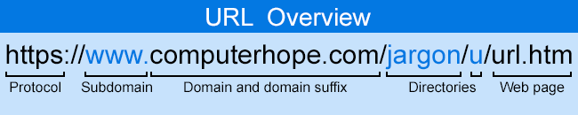

* **HTML**

HTML is an acronym which stands for **Hyper Text Markup Language** which is used for creating web pages and web applications. Let's see what is meant by Hypertext Markup Language, and Web page.

**Hyper Text:** HyperText simply means "Text within Text." A text has a link within it, is a hypertext. Whenever you click on a link which

brings you to a new webpage, you have clicked on a hypertext. HyperText is a way to link two or more web pages (HTML documents) with each other.

**Markup language:** A markup language is a computer language that is used to apply layout and formatting conventions to a text document. Markup language makes text more interactive and dynamic. It can turn text into images, tables, links, etc.

**Web Page:** A web page is a document which is commonly written in HTML and translated by a web browser. A web page can be identified by entering an URL. A Web page can be of the static or dynamic type. **With the help of HTML only, we can create static web pages.**

##### CSS

CSS is used to control the style of a web document in a simple and easy way. **CSS** is the acronym for "**Cascading Style Sheet"**.

##### What is JavaScript?

**JavaScript (JS)** is a lightweight, interpreted, or just-intime compiled programming language with first-class functions. While it is most well-known as the scripting language for Web pages, many nonbrowser environments also use it, such as Node.js, Apache CouchDB and Adobe Acrobat. JavaScript is a prototype-based, multiparadigm, single-threaded, dynamic language, supporting objectoriented, imperative, and declarative (e.g.

functional programming) styles.

JavaScript's dynamic capabilities include runtime object construction, variable parameter lists, function variables, dynamic script creation (via eval), object introspection (via for...in and Object utilities), and source- code recovery (JavaScript functions store their source text and can be retrieved through toString()).

##### What is Bootstrap?

Bootstrap is a free and open-source tool collection for creating responsive websites and web applications. It is the most popular HTML, CSS, and JavaScript framework for developing responsive, mobile-first websites. Nowadays, the websites are perfect for all browsers (IE, Firefox, and Chrome) and for all sizes of screens (Desktop, Tablets, Phablets, and Phones).

##### What is Php?

**PHP (Hypertext Preprocessor)** is a popular open- source server-side scripting language designed for web development. It is embedded within HTML and is used to create dynamic web pages and web applications. When a PHP script runs on a web server, it can generate HTML, manage sessions, interact with databases, and perform various tasks

that enable websites to function interactively. Key features of PHP include:

1. **Server-Side Scripting:** PHP code is executed on the server, and the result is sent to the client's browser as plain HTML.
2. **Database Interaction:** PHP can interact with various databases like MySQL, PostgreSQL, and SQLite, making it suitable for creating dynamic content like user profiles, content management systems, and online stores.
3. **Cross-Platform Compatibility:** PHP runs on various platforms such as Windows, Linux, and macOS, and is supported by almost all web servers (e.g., Apache, Nginx).

PHP is especially favored for web development due to its flexibility, ease of use, and broad community support.

##### What is SQL ?

**SQL** is a language to operate databases; it includes Database Creation, Database Deletion, Fetching Data Rows, Modifying & Deleting Data rows, etc.

SQL stands for **Structured Query Language** which is a computer language for storing, manipulating and retrieving data stored in a relational database.

SQL was developed in the 1970s by IBM Computer Scientists and became a standard of the American National Standards Institute (ANSI) in 1986, and the International Organization for Standardization (ISO) in 1987.SQL is the standard language to communicate with Relational Database Systems. All the Relational Database Management Systems

(RDMS) like MySQL, MS Access, Oracle, Sybase, Informix, Postgres and SQL Server use SQL as their Standard Database Language.

Though SQL is an **ANSI** (American National Standards Institute) standard language, but there are many different dialects of the SQL language like MS SQL Server is using T-SQL and Oracle is using PL/SQL.

##### What is FTP?

* + - FTP stands for File transfer protocol.
    - FTP is a standard internet protocol provided by TCP/IP used for transmitting the files from one host to another.
    - It is mainly used for transferring the web page files from their creator to the computer that acts as a server for other computers on the internet.
    - It is also used for downloading the files to computer from other servers.

##### Feasibility Study

A feasibility study evaluates a project's or system's practicality. As part of a feasibility study, the objective and rational analysis of a potential business or venture is conducted to determine its strengths and weaknesses, potential opportunities and threats, resources required to carry out, and ultimate success prospects. Two criteria should be considered when judging feasibility: the required cost and expected value.

**Types of Feasibility Study**

There are five types of feasibility study—separate areas that a feasibility study examines, described below.

1. **Technical Feasibility**

This assessment focuses on the technical resources available to the organization. It helps organizations determine whether the technical resources meet capacity and whether the technical team is capable of converting the ideas into working systems. Technical

feasibility also involves the evaluation of the hardware, software, and other technical requirements of the proposed system. As an exaggerated example, an organization wouldn’t want to try to put Star Trek’s transporters in their building—currently, this project is not technically feasible.

1. **Economic Feasibility**

This assessment typically involves a cost/ benefits analysis of the project, helping organizations determine the viability, cost, and benefits associated with a project before financial resources are allocated. It also serves as an independent project assessment and enhances project credibility—helping decision-makers determine the positive economic benefits to the organization that the proposed project will provide.

1. **Legal Feasibility**

This assessment investigates whether any aspect of the proposed project conflicts with legal requirements like zoning laws, data protection acts or social media laws. Let’s say an organization wants to construct a new office building in a specific location. A feasibility study might reveal the organization’s ideal location isn’t zoned for that type of business. That organization has just saved considerable time and effort by learning that their project was not feasible right from the beginning.

1. **Operational Feasibility**

This assessment involves undertaking a study to analyze and determine whether—and how well—the organization’s needs can be met by completing the project. Operational feasibility studies also examine how a project plan satisfies the requirements identified in the requirements analysis phase of system development.

1. **Scheduling Feasibility**

This assessment is the most important for project success; after all, a project will fail if not completed on time. In scheduling feasibility, an organization estimates how much time the project will take to complete.

##### SDT(Software Development Tools)

A software development tool is a program or application that is used to aid in the process of developing software. There are many different types of software development tools, and they can be used for a wide range of tasks, such as writing and editing code, debugging software, managing version control, and building and deploying software applications. Some common examples of software development tools include text editors, integrated development environments (IDEs), debugger tools, version control systems, and build automation tools. Software development tools can be used by individual developers or by teams of developers working on a software project. They are an essential part of the software development process and can help to improve efficiency and productivity.

The SDT which we have used in our project is:-

1) PHP 2)HTML5 3)CSS3

1. JavaScript
2. Bootstrap5
3. MySQL





*Hardware Requirements

* **Processor:** Minimum 1 GHz; Recommended 2GHz or more
* Ethernet connection (LAN) OR a wireless adapter (Wi-Fi)
* **Hard Drive:** Minimum 32 GB; Recommended 64 GB or more
* **Memory (RAM):** Minimum 1 GB; Recommended 4 GB or above

*Software Requirements

* **Operating system :** Windows 10.
* **Coding Language :** PHP

**SDLC(Software Development Life Cycle) –**

SDLC stands for "Software Development Life Cycle." It is a process that is followed for developing software systems. The SDLC process defines the steps that are involved in developing a software system, from the initial planning stages to the final deployment of the software. There are several different models that can be used to guide the SDLC process, each with its own set of steps and activities . Some common SDLC models include the Waterfall model, the Agile model, the Spiral model, and the V-shaped model.

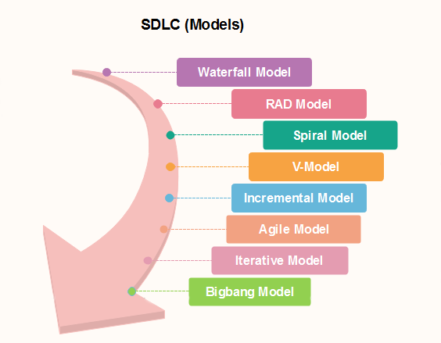

The Waterfall model is a linear model that follows a strict set of steps, with each step building upon the previous one. The Agile model is a flexible, iterative approach that allows for frequent changes and adaptations during the development process. The Spiral model is a riskdriven approach that involves iterative development and risk assessment. The V-shaped model is a combination of the Waterfall model and the Iterative model, with each step in the process followed in

a linear fashion, but with the possibility of returning to earlier steps if necessary.

##### Waterfall Model

The waterfall is a universally accepted SDLC model. In this method, the whole process of software development is divided into various phases.

Linear ordering of activities has some significant consequences. First, to identify the end of a phase and the beginning of the next, some certification techniques have to be employed at the end of each step. Some verification and validation usually do this mean that will ensure that the output of the stage is consistent with its input (which is the output of the previous step), and that the output of the stage is consistent with the overall requirements of the system.

##### ncremental Model in SDLC

The incremental model is not a separate model. It is essentially a series of waterfall cycles. The requirements are divided into groups at the start of the project. For each group, the SDLC model is followed to develop software. The SDLC life cycle process is repeated, with each release adding more functionality until all requirements are met. In this method, every cycle act as the maintenance phase for the previous software 15 release. Modification to the incremental model allows development cycles to overlap. After that subsequent cycle may begin before the previous cycle is complete.

##### V-Model in SDLC

In this type of SDLC model testing and the development, the phase is planned in parallel. So, there are verification phases of SDLC on the side and the validation phase on the other side. V-Model joins by Coding phase.

##### Agile Model in SDLC

Agile methodology is a practice which promotes continue interaction of development and testing during the SDLC process of any project. In the

Agile method, the entire project is divided into small incremental builds. All of these builds are provided in iterations, and each iteration lasts from one to three weeks.

##### Big bang model

Big bang model is focusing on all types of resources in software development and coding, with no or very little planning. The requirements are understood and implemented when they come. This model works best for small projects with smaller size development team which are working together. It is also useful for academic software development projects. It is an ideal model where requirements is either unknown or final release date is not given.

##### RAD Model

RAD or Rapid Application Development process is an adoption of the waterfall model; it targets developing software in a short period. The RAD model is based on the concept that a better system can be developed in lesser time by using focus groups to gather system requirements.

* Business Modeling
* Data Modeling
  + Process Modeling
  + Application Generation

##### Spiral model

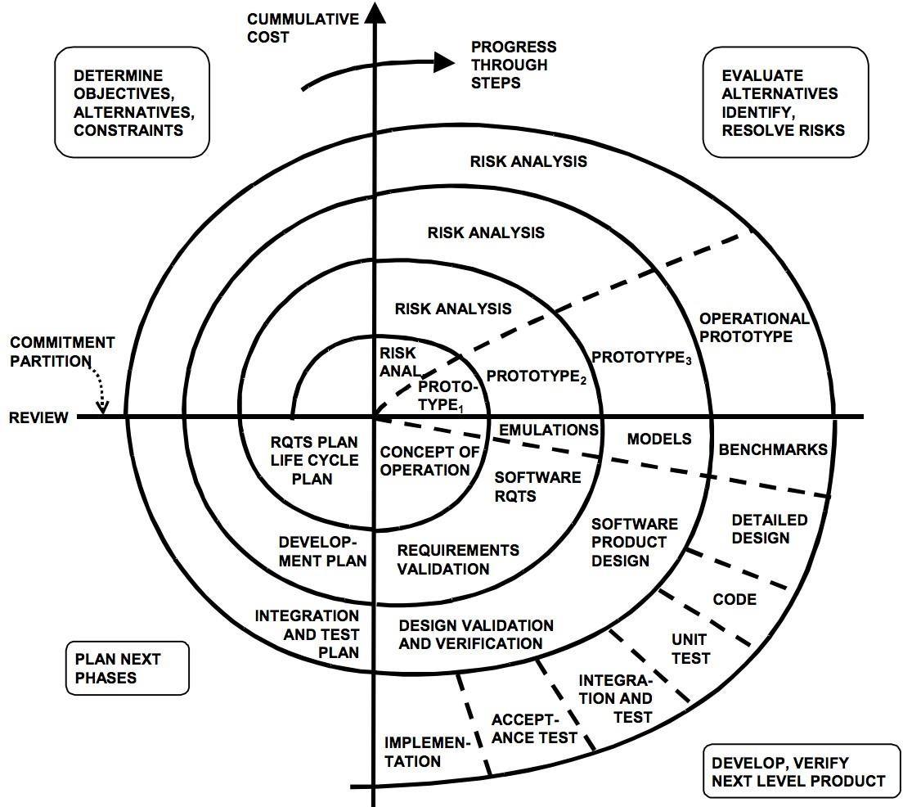

**Why we are using Spiral SDLC model in our project –**

The Spiral SDLC model is a risk-driven software development process model that is based on the idea of prototyping. In this model, the development process begins with a small set of requirements that are refined as the project progresses through multiple cycles, or "spirals." Each cycle consists of four phases: planning, risk analysis, engineering, and evaluation. One of the main benefits of the Spiral model is that it allows for a high level of flexibility and iteration, which can be particularly useful in projects where requirements are not well-defined or are likely to change significantly over the course of the project. It can also be useful in projects where there are a lot of unknowns or high levels of risk, as it allows for a systematic approach to identifying and addressing these risks.

Overall, the Spiral model can be a good choice for projects where a high level of collaboration and risk management is required, and where the

development team needs to be able to adapt and respond to changing requirements as the project progresses.

##### Software Project Planning :

Project planning is an organized and integrated management process that focuses on the actions necessary for the project's practical completion. It avoids problems in the project, such as changes in the project's or organization's objectives, resource shortages, and so forth. Project planning also aids in improved resource use, and the most efficient use of a project's allowed time. The following are the other project planning goals. Estimating the subsequent attributes of the project:

* + - **Project size:**

What’s going to be downside quality in terms of the trouble

and time needed to develop the product?

* + - **Cost:**

What proportion is it reaching to value to develop the project?

* + - **Duration:**

However long is it reaching to want complete development?

* + - **Effort:**

What proportion effort would be required?

The effectiveness of the following designing activities relies on the accuracy of those estimations.

* + - * planning force and alternative resources
      * workers organization and staffing plans
      * Risk identification, analysis, and abatement designing
      * Miscellaneous arranges like quality assurance plan, configuration, management arrange, etc.

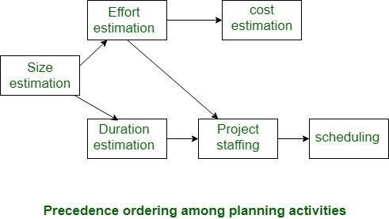

##### System Design:

System design is the process of designing the elements of a system such as the architecture, modules and components, the different interfaces of those components and the data that goes through that system.System Analysis is the process that decomposes a system into its component pieces for the purpose of defining how well those components interact to accomplish the set requirements.

There are several strategies that can be used to design software systems, including the following:

1. **Top-Down Design:** This strategy starts with a high-level view of the system and gradually breaks it down into smaller, more manageable components.
2. **Bottom-Up Design:** This strategy starts with individual components and builds the system up, piece by piece.
3. **Iterative Design:** This strategy involves designing and implementing the system in stages, with each stage building on the results of the previous stage.
4. **Incremental Design:** This strategy involves designing and implementing a small part of the system at a time, adding more functionality with each iteration.
5. **Agile Design:** This strategy involves a flexible, iterative approach to design, where requirements and design evolve through collaboration between self-organizing and cross-functional teams.

**Gantt Chart**

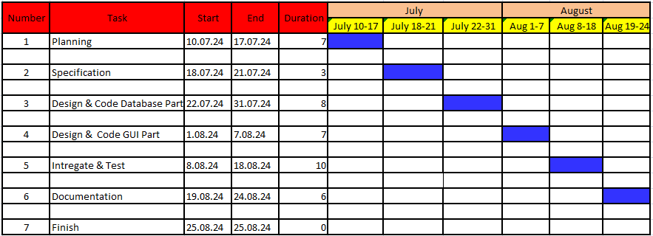

**PERT CHART**

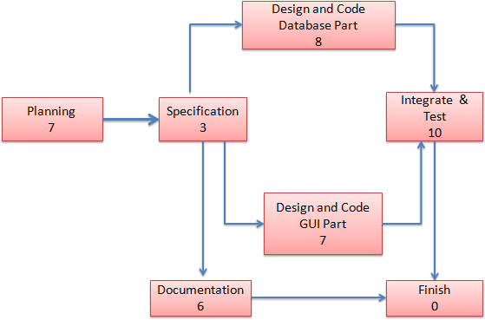

**FLOW CHART**

Products

Admin Login

Sundarban Developement

Manage Products

Service Products

Buy Products

Show Products

Add

List

Log Out

Accept and Delete Orders

List Products

Add Products

Log Out

# ER Diagram

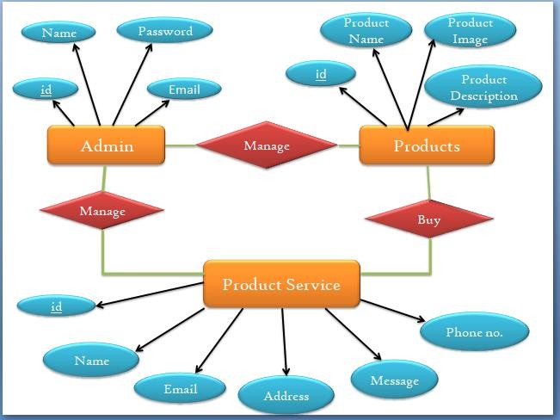

### DFD(Data Flow Diagram)

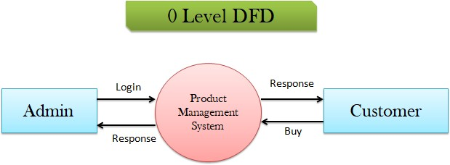

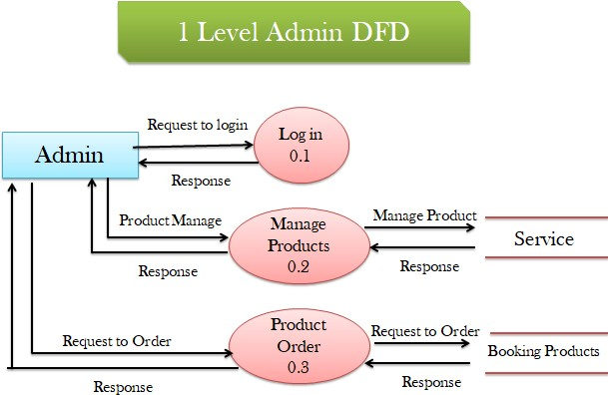

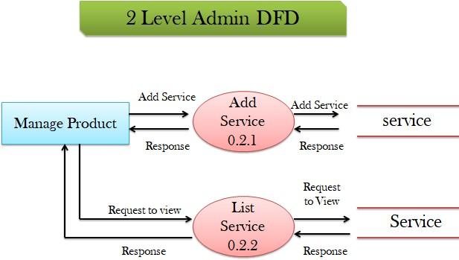

**CODE:-**

1. **INDEX.PHP**

<?php

session_start();

include("admin_ins/db.php");

if(isset($_POST['login'])){

$e=$_POST['email'];

$p=$_POST['pass'];

$sel="SELECT * FROM admin WHERE email='$e' AND password='$p'";

$rs=$con->query($sel);

if($rs->num_rows>0){

    $data=$rs->fetch_assoc();

    $_SESSION['admin_name']=$data['name'];

    header("location:dashboard.php");

}else{

    $err= "Invalid Login";

}

}

?>

<!DOCTYPE html>

<html lang="en">

<head>

    <meta charset="utf-8">

    <meta http-equiv="X-UA-Compatible" content="IE=edge">

    <meta name="viewport" content="width=device-width, initial-scale=1, shrink-to-fit=no">

    <meta name="description" content="">

    <meta name="author" content="">

    <title>SB Admin 2 - Login</title>

    <!-- Custom fonts for this template-->

    <link href="vendor/fontawesome-free/css/all.min.css" rel="stylesheet" type="text/css">

    <link

        href="https://fonts.googleapis.com/css?family=Nunito:200,200i,300,300i,400,400i,600,600i,700,700i,800,800i,900,900i"

        rel="stylesheet">

    <!-- Custom styles for this template-->

    <link href="css/sb-admin-2.min.css" rel="stylesheet">

</head>

<body class="bg-gradient-primary">

    <div class="container">

        <!-- Outer Row -->

        <div class="row justify-content-center">

            <div class="col-xl-10 col-lg-12 col-md-9">

                <div class="card o-hidden border-0 shadow-lg my-5">

                    <div class="card-body p-0">

                        <!-- Nested Row within Card Body -->

                        <div class="row">

                            <div class="col-lg-6 d-none d-lg-block bg-login-image"></div>

                            <div class="col-lg-6">

                                <div class="p-5">

                                    <div class="text-center">

                                        <h1 class="h4 text-gray-900 mb-4">Welcome Back!</h1>

                                    </div>

<?php if(isset($err)){ ?>

<div class="alert alert-danger">

  <strong>Error!</strong> <?php echo $err; ?>

</div>

<?php } ?>

                                    <form class="user" action="" method="post" >

                                        <div class="form-group">

                                            <input  name="email" type="email" class="form-control form-control-user"

                                                id="exampleInputEmail" aria-describedby="emailHelp"

                                                placeholder="Enter Email Address...">

                                        </div>

                                        <div class="form-group">

                                            <input type="password" name="pass" class="form-control form-control-user"

                                                id="exampleInputPassword" placeholder="Password">

                                        </div>

                                        <div class="form-group">

                                        </div>

                                    <input class="btn btn-primary btn-user btn-block"  type="submit" name="login" value="login"  />

                                    </form>

                                </div>

                            </div>

                        </div>

                    </div>

                </div>

            </div>

        </div>

    </div>

    <!-- Bootstrap core JavaScript-->

    <script src="vendor/jquery/jquery.min.js"></script>

    <script src="vendor/bootstrap/js/bootstrap.bundle.min.js"></script>

    <!-- Core plugin JavaScript-->

    <script src="vendor/jquery-easing/jquery.easing.min.js"></script>

    <!-- Custom scripts for all pages-->

    <script src="js/sb-admin-2.min.js"></script>

</body>

</html>

1. **CONTACT.PHP**

<!DOCTYPE html>

<html lang="zxx">

<head>

    <title>Grocery Shoppy an Ecommerce Category Bootstrap Responsive Web Template | Contact Us :: w3layouts</title>

    <!--/tags -->

    <meta name="viewport" content="width=device-width, initial-scale=1">

    <meta http-equiv="Content-Type" content="text/html; charset=utf-8" />

    <meta name="keywords" content="Grocery Shoppy Responsive web template, Bootstrap Web Templates, Flat Web Templates, Android Compatible web template,

Smartphone Compatible web template, free webdesigns for Nokia, Samsung, LG, SonyEricsson, Motorola web design" />

    <script>

        addEventListener("load", function () {

            setTimeout(hideURLbar, 0);

        }, false);

        function hideURLbar() {

            window.scrollTo(0, 1);

        }

    </script>

    <!--//tags -->

    <link href="css/bootstrap.css" rel="stylesheet" type="text/css" media="all" />

    <link href="css/style.css" rel="stylesheet" type="text/css" media="all" />

    <link href="css/font-awesome.css" rel="stylesheet">

    <!--pop-up-box-->

    <link href="css/popuo-box.css" rel="stylesheet" type="text/css" media="all" />

    <!--//pop-up-box-->

    <!-- price range -->

    <link rel="stylesheet" type="text/css" href="css/jquery-ui1.css">

    <!-- fonts -->

    <link href="//fonts.googleapis.com/css?family=Open+Sans:300,300i,400,400i,600,600i,700,700i,800" rel="stylesheet">

</head>

<body>

    <!-- top-header -->

    <div class="header-most-top">

        <p>Sundarban's All Products Offer Zone Top Deals & Discounts</p>

    </div>

    <!-- //top-header -->

    <!-- header-bot-->

    <div class="header-bot">

        <div class="header-bot_inner_wthreeinfo_header_mid">

            <!-- header-bot-->

            <div class="col-md-4 logo_agile">

                <h1>

                    <a href="index.html">

                        <span>G</span>rocery

                        <span>S</span>hoppy

                        <img src="images/logo2.png" alt=" ">

                    </a>

                </h1>

            </div>

            <!-- header-bot -->

            <div class="col-md-8 header">

                <!-- header lists -->

                <ul>

                    <li>

                        <a class="play-icon popup-with-zoom-anim" href="#small-dialog1">

                            <span class="fa fa-map-marker" aria-hidden="true"></span> Shop Locator</a>

                    </li>

                    <li>

                        <a href="#" data-toggle="modal" data-target="#myModal1">

                            <span class="fa fa-truck" aria-hidden="true"></span>Track Order</a>

                    </li>

                    <li>

                        <span class="fa fa-phone" aria-hidden="true"></span> 001 234 5678

                    </li>

                    <li>

                        <a href="#" data-toggle="modal" data-target="#myModal1">

                            <span class="fa fa-unlock-alt" aria-hidden="true"></span> Sign In </a>

                    </li>

                    <li>

                        <a href="#" data-toggle="modal" data-target="#myModal2">

                            <span class="fa fa-pencil-square-o" aria-hidden="true"></span> Sign Up </a>

                    </li>

                </ul>

                <!-- //header lists -->

                <!-- search -->

                <div class="agileits_search">

                    <form action="#" method="post">

                        <input name="Search" type="search" placeholder="How can we help you today?" required="">

                        <button type="submit" class="btn btn-default" aria-label="Left Align">

                            <span class="fa fa-search" aria-hidden="true"> </span>

                        </button>

                    </form>

                </div>

                <!-- //search -->

                <!-- cart details -->

                <div class="top_nav_right">

                    <div class="wthreecartaits wthreecartaits2 cart cart box_1">

                        <form action="#" method="post" class="last">

                            <input type="hidden" name="cmd" value="_cart">

                            <input type="hidden" name="display" value="1">

                            <button class="w3view-cart" type="submit" name="submit" value="">

                                <i class="fa fa-cart-arrow-down" aria-hidden="true"></i>

                            </button>

                        </form>

                    </div>

                </div>

                <!-- //cart details -->

                <div class="clearfix"></div>

            </div>

            <div class="clearfix"></div>

        </div>

    </div>

    <!-- shop locator (popup) -->

    <!-- Button trigger modal(shop-locator) -->

    <div id="small-dialog1" class="mfp-hide">

        <div class="select-city">

            <h3>Please Select Your Location</h3>

            <select class="list_of_cities">

                <optgroup label="Popular Cities">

                    <option selected style="display:none;color:#eee;">Select City</option>

                    <option>Birmingham</option>

                    <option>Anchorage</option>

                    <option>Phoenix</option>

                    <option>Little Rock</option>

                    <option>Los Angeles</option>

                    <option>Denver</option>

                    <option>Bridgeport</option>

                    <option>Wilmington</option>

                    <option>Jacksonville</option>

                    <option>Atlanta</option>

                    <option>Honolulu</option>

                    <option>Boise</option>

                    <option>Chicago</option>

                    <option>Indianapolis</option>

                </optgroup>

                <optgroup label="Alabama">

                    <option>Birmingham</option>

                    <option>Montgomery</option>

                    <option>Mobile</option>

                    <option>Huntsville</option>

                    <option>Tuscaloosa</option>

                </optgroup>

                <optgroup label="Alaska">

                    <option>Anchorage</option>

                    <option>Fairbanks</option>

                    <option>Juneau</option>

                    <option>Sitka</option>

                    <option>Ketchikan</option>

                </optgroup>

                <optgroup label="Arizona">

                    <option>Phoenix</option>

                    <option>Tucson</option>

                    <option>Mesa</option>

                    <option>Chandler</option>

                    <option>Glendale</option>

                </optgroup>

                <optgroup label="Arkansas">

                    <option>Little Rock</option>

                    <option>Fort Smith</option>

                    <option>Fayetteville</option>

                    <option>Springdale</option>

                    <option>Jonesboro</option>

                </optgroup>

                <optgroup label="California">

                    <option>Los Angeles</option>

                    <option>San Diego</option>

                    <option>San Jose</option>

                    <option>San Francisco</option>

                    <option>Fresno</option>

                </optgroup>

                <optgroup label="Colorado">

                    <option>Denver</option>

                    <option>Colorado</option>

                    <option>Aurora</option>

                    <option>Fort Collins</option>

                    <option>Lakewood</option>

                </optgroup>

                <optgroup label="Connecticut">

                    <option>Bridgeport</option>

                    <option>New Haven</option>

                    <option>Hartford</option>

                    <option>Stamford</option>

                    <option>Waterbury</option>

                </optgroup>

                <optgroup label="Delaware">

                    <option>Wilmington</option>

                    <option>Dover</option>

                    <option>Newark</option>

                    <option>Bear</option>

                    <option>Middletown</option>

                </optgroup>

                <optgroup label="Florida">

                    <option>Jacksonville</option>

                    <option>Miami</option>

                    <option>Tampa</option>

                    <option>St. Petersburg</option>

                    <option>Orlando</option>

                </optgroup>

                <optgroup label="Georgia">

                    <option>Atlanta</option>

                    <option>Augusta</option>

                    <option>Columbus</option>

                    <option>Savannah</option>

                    <option>Athens</option>

                </optgroup>

                <optgroup label="Hawaii">

                    <option>Honolulu</option>

                    <option>Pearl City</option>

                    <option>Hilo</option>

                    <option>Kailua</option>

                    <option>Waipahu</option>

                </optgroup>

                <optgroup label="Idaho">

                    <option>Boise</option>

                    <option>Nampa</option>

                    <option>Meridian</option>

                    <option>Idaho Falls</option>

                    <option>Pocatello</option>

                </optgroup>

                <optgroup label="Illinois">

                    <option>Chicago</option>

                    <option>Aurora</option>

                    <option>Rockford</option>

                    <option>Joliet</option>

                    <option>Naperville</option>

                </optgroup>

                <optgroup label="Indiana">

                    <option>Indianapolis</option>

                    <option>Fort Wayne</option>

                    <option>Evansville</option>

                    <option>South Bend</option>

                    <option>Hammond</option>

                </optgroup>

                <optgroup label="Iowa">

                    <option>Des Moines</option>

                    <option>Cedar Rapids</option>

                    <option>Davenport</option>

                    <option>Sioux City</option>

                    <option>Waterloo</option>

                </optgroup>

                <optgroup label="Kansas">

                    <option>Wichita</option>

                    <option>Overland Park</option>

                    <option>Kansas City</option>

                    <option>Topeka</option>

                    <option>Olathe  </option>

                </optgroup>

                <optgroup label="Kentucky">

                    <option>Louisville</option>

                    <option>Lexington</option>

                    <option>Bowling Green</option>

                    <option>Owensboro</option>

                    <option>Covington</option>

                </optgroup>

                <optgroup label="Louisiana">

                    <option>New Orleans</option>

                    <option>Baton Rouge</option>

                    <option>Shreveport</option>

                    <option>Metairie</option>

                    <option>Lafayette</option>

                </optgroup>

                <optgroup label="Maine">

                    <option>Portland</option>

                    <option>Lewiston</option>

                    <option>Bangor</option>

                    <option>South Portland</option>

                    <option>Auburn</option>

                </optgroup>

                <optgroup label="Maryland">

                    <option>Baltimore</option>

                    <option>Frederick</option>

                    <option>Rockville</option>

                    <option>Gaithersburg</option>

                    <option>Bowie</option>

                </optgroup>

                <optgroup label="Massachusetts">

                    <option>Boston</option>

                    <option>Worcester</option>

                    <option>Springfield</option>

                    <option>Lowell</option>

                    <option>Cambridge</option>

                </optgroup>

                <optgroup label="Michigan">

                    <option>Detroit</option>

                    <option>Grand Rapids</option>

                    <option>Warren</option>

                    <option>Sterling Heights</option>

                    <option>Lansing</option>

                </optgroup>

                <optgroup label="Minnesota">

                    <option>Minneapolis</option>

                    <option>St. Paul</option>

                    <option>Rochester</option>

                    <option>Duluth</option>

                    <option>Bloomington</option>

                </optgroup>

                <optgroup label="Mississippi">

                    <option>Jackson</option>

                    <option>Gulfport</option>

                    <option>Southaven</option>

                    <option>Hattiesburg</option>

                    <option>Biloxi</option>

                </optgroup>

                <optgroup label="Missouri">

                    <option>Kansas City</option>

                    <option>St. Louis</option>

                    <option>Springfield</option>

                    <option>Independence</option>

                    <option>Columbia</option>

                </optgroup>

                <optgroup label="Montana">

                    <option>Billings</option>

                    <option>Missoula</option>

                    <option>Great Falls</option>

                    <option>Bozeman</option>

                    <option>Butte-Silver Bow</option>

                </optgroup>

                <optgroup label="Nebraska">

                    <option>Omaha</option>

                    <option>Lincoln</option>

                    <option>Bellevue</option>

                    <option>Grand Island</option>

                    <option>Kearney</option>

                </optgroup>

                <optgroup label="Nevada">

                    <option>Las Vegas</option>

                    <option>Henderson</option>

                    <option>North Las Vegas</option>

                    <option>Reno</option>

                    <option>Sunrise Manor</option>

                </optgroup>

                <optgroup label="New Hampshire">

                    <option>Manchesters</option>

                    <option>Nashua</option>

                    <option>Concord</option>

                    <option>Dover</option>

                    <option>Rochester</option>

                </optgroup>

                <optgroup label="New Jersey">

                    <option>Newark</option>

                    <option>Jersey City</option>

                    <option>Paterson</option>

                    <option>Elizabeth</option>

                    <option>Edison</option>

                </optgroup>

                <optgroup label="New Mexico">

                    <option>Albuquerque</option>

                    <option>Las Cruces</option>

                    <option>Rio Rancho</option>

                    <option>Santa Fe</option>

                    <option>Roswell</option>

                </optgroup>

                <optgroup label="New York">

                    <option>New York</option>

                    <option>Buffalo</option>

                    <option>Rochester</option>

                    <option>Yonkers</option>

                    <option>Syracuse</option>

                </optgroup>

                <optgroup label="North Carolina">

                    <option>Charlotte</option>

                    <option>Raleigh</option>

                    <option>Greensboro</option>

                    <option>Winston-Salem</option>

                    <option>Durham</option>

                </optgroup>

                <optgroup label="North Dakota">

                    <option>Fargo</option>

                    <option>Bismarck</option>

                    <option>Grand Forks</option>

                    <option>Minot</option>

                    <option>West Fargo</option>

                </optgroup>

                <optgroup label="Ohio">

                    <option>Columbus</option>

                    <option>Cleveland</option>

                    <option>Cincinnati</option>

                    <option>Toledo</option>

                    <option>Akron</option>

                </optgroup>

                <optgroup label="Oklahoma">

                    <option>Oklahoma City</option>

                    <option>Tulsa</option>

                    <option>Norman</option>

                    <option>Broken Arrow</option>

                    <option>Lawton</option>

                </optgroup>

                <optgroup label="Oregon">

                    <option>Portland</option>

                    <option>Eugene</option>

                    <option>Salem</option>

                    <option>Gresham</option>

                    <option>Hillsboro</option>

                </optgroup>

                <optgroup label="Pennsylvania">

                    <option>Philadelphia</option>

                    <option>Pittsburgh</option>

                    <option>Allentown</option>

                    <option>Erie</option>

                    <option>Reading</option>

                </optgroup>

                <optgroup label="Rhode Island">

                    <option>Providence</option>

                    <option>Warwick</option>

                    <option>Cranston</option>

                    <option>Pawtucket</option>

                    <option>East Providence</option>

                </optgroup>

                <optgroup label="South Carolina">

                    <option>Columbia</option>

                    <option>Charleston</option>

                    <option>North Charleston</option>

                    <option>Mount Pleasant</option>

                    <option>Rock Hill</option>

                </optgroup>

                <optgroup label="South Dakota">

                    <option>Sioux Falls</option>

                    <option>Rapid City</option>

                    <option>Aberdeen</option>

                    <option>Brookings</option>

                    <option>Watertown</option>

                </optgroup>

                <optgroup label="Tennessee">

                    <option>Memphis</option>

                    <option>Nashville</option>

                    <option>Knoxville</option>

                    <option>Chattanooga</option>

                    <option>Clarksville</option>

                </optgroup>

                <optgroup label="Texas">

                    <option>Houston</option>

                    <option>San Antonio</option>

                    <option>Dallas</option>

                    <option>Austin</option>

                    <option>Fort Worth</option>

                </optgroup>

                <optgroup label="Utah">

                    <option>Salt Lake City</option>

                    <option>West Valley City</option>

                    <option>Provo</option>

                    <option>West Jordan</option>

                    <option>Orem</option>

                </optgroup>

                <optgroup label="Vermont">

                    <option>Burlington</option>

                    <option>Essex</option>

                    <option>South Burlington</option>

                    <option>Colchester</option>

                    <option>Rutland</option>

                </optgroup>

                <optgroup label="Virginia">

                    <option>Virginia Beach</option>

                    <option>Norfolk</option>

                    <option>Chesapeake</option>

                    <option>Arlington</option>

                    <option>Richmond</option>

                </optgroup>

                <optgroup label="Washington">

                    <option>Seattle</option>

                    <option>Spokane</option>

                    <option>Tacoma</option>

                    <option>Vancouver</option>

                    <option>Bellevue</option>

                </optgroup>

                <optgroup label="West Virginia">

                    <option>Charleston</option>

                    <option>Huntington</option>

                    <option>Parkersburg</option>

                    <option>Morgantown</option>

                    <option>Wheeling</option>

                </optgroup>

                <optgroup label="Wisconsin">

                    <option>Milwaukee</option>

                    <option>Madison</option>

                    <option>Green Bay</option>

                    <option>Kenosha</option>

                    <option>Racine</option>

                </optgroup>

                <optgroup label="Wyoming">

                    <option>Cheyenne</option>

                    <option>Casper</option>

                    <option>Laramie</option>

                    <option>Gillette</option>

                    <option>Rock Springs</option>

                </optgroup>

            </select>

            <div class="clearfix"></div>

        </div>

    </div>

    <!-- //shop locator (popup) -->

    <!-- signin Model -->

    <!-- Modal1 -->

    <div class="modal fade" id="myModal1" tabindex="-1" role="dialog">

        <div class="modal-dialog">

            <!-- Modal content-->

            <div class="modal-content">

                <div class="modal-header">

                    <button type="button" class="close" data-dismiss="modal">&times;</button>

                </div>

                <div class="modal-body modal-body-sub_agile">

                    <div class="main-mailposi">

                        <span class="fa fa-envelope-o" aria-hidden="true"></span>

                    </div>

                    <div class="modal_body_left modal_body_left1">

                        <h3 class="agileinfo_sign">Sign In </h3>

                        <p>

                            Sign In now, Let's start your Grocery Shopping. Don't have an account?

                            <a href="#" data-toggle="modal" data-target="#myModal2">

                                Sign Up Now</a>

                        </p>

                        <form action="#" method="post">

                            <div class="styled-input agile-styled-input-top">

                                <input type="text" placeholder="User Name" name="Name" required="">

                            </div>

                            <div class="styled-input">

                                <input type="password" placeholder="Password" name="password" required="">

                            </div>

                            <input type="submit" value="Sign In">

                        </form>

                        <div class="clearfix"></div>

                    </div>

                    <div class="clearfix"></div>

                </div>

            </div>

            <!-- //Modal content-->

        </div>

    </div>

    <!-- //Modal1 -->

    <!-- //signin Model -->

    <!-- signup Model -->

    <!-- Modal2 -->

    <div class="modal fade" id="myModal2" tabindex="-1" role="dialog">

        <div class="modal-dialog">

            <!-- Modal content-->

            <div class="modal-content">

                <div class="modal-header">

                    <button type="button" class="close" data-dismiss="modal">&times;</button>

                </div>

                <div class="modal-body modal-body-sub_agile">

                    <div class="main-mailposi">

                        <span class="fa fa-envelope-o" aria-hidden="true"></span>

                    </div>

                    <div class="modal_body_left modal_body_left1">

                        <h3 class="agileinfo_sign">Sign Up</h3>

                        <p>

                            Come join the Grocery Shoppy! Let's set up your Account.

                        </p>

                        <form action="#" method="post">

                            <div class="styled-input agile-styled-input-top">

                                <input type="text" placeholder="Name" name="Name" required="">

                            </div>

                            <div class="styled-input">

                                <input type="email" placeholder="E-mail" name="Email" required="">

                            </div>

                            <div class="styled-input">

                                <input type="password" placeholder="Password" name="password" id="password1" required="">

                            </div>

                            <div class="styled-input">

                                <input type="password" placeholder="Confirm Password" name="Confirm Password" id="password2" required="">

                            </div>

                            <input type="submit" value="Sign Up">

                        </form>

                        <p>

                            <a href="#">By clicking register, I agree to your terms</a>

                        </p>

                    </div>

                </div>

            </div>

            <!-- //Modal content-->

        </div>

    </div>

    <!-- //Modal2 -->

    <!-- //signup Model -->

    <!-- //header-bot -->

    <!-- navigation -->

    <div class="ban-top">

        <div class="container">

            <div class="agileits-navi_search">

                <form action="#" method="post">

                    <select id="agileinfo-nav_search" name="agileinfo_search" required="">

                        <option value="">All Categories</option>

                        <option value="Honey">Honey</option>

                        <option value="Fish and Seafood">Fish and Seafood</option>

                        <option value="Timber and Wood Products ">Timber and Wood Products</option>

                        <option value="Nipa Palm Products">Nipa Palm Products</option>

                        <option value="Medicinal Plants">Medicinal Plants</option>

                        <option value="Agricultural Products">Agricultural Products</option>

                        <option value="Processed Seafood">Processed Seafood</option>

                        <option value="Honey-Based Products">Honey-Based Products</option>

                        <option value="Wood and Bamboo Products">Wood and Bamboo Products</option>

                        <option value="Handicrafts">Handicrafts</option>

                        <option value="Nipa Palm Derivatives">Nipa Palm Derivatives</option>

                    </select>

                </form>

            </div>

            <div class="top_nav_left">

                <nav class="navbar navbar-default">

                    <div class="container-fluid">

                        <!-- Brand and toggle get grouped for better mobile display -->

                        <div class="navbar-header">

                            <button type="button" class="navbar-toggle collapsed" data-toggle="collapse" data-target="#bs-example-navbar-collapse-1"

                                aria-expanded="false">

                                <span class="sr-only">Toggle navigation</span>

                                <span class="icon-bar"></span>

                                <span class="icon-bar"></span>

                                <span class="icon-bar"></span>

                            </button>

                        </div>

                        <!-- Collect the nav links, forms, and other content for toggling -->

                        <?php include('ins/header.php'); ?>

                    </div>

                </nav>

            </div>

        </div>

    </div>

    <!-- //navigation -->

    <!-- banner-2 -->

    <div class="page-head_agile_info_w3l">

    </div>

    <!-- //banner-2 -->

    <!-- page -->

    <div class="services-breadcrumb">

        <div class="agile_inner_breadcrumb">

            <div class="container">

                <ul class="w3_short">

                    <li>

                        <a href="index.html">Home</a>

                        <i>|</i>

                    </li>

                    <li>contact Us</li>

                </ul>

            </div>

        </div>

    </div>

    <!-- //page -->

    <!-- contact page -->

    <div class="contact-w3l">

        <div class="container">

            <!-- tittle heading -->

            <h3 class="tittle-w3l">Contact Us

                <span class="heading-style">

                    <i></i>

                    <i></i>

                    <i></i>

                </span>

            </h3>

            <!-- //tittle heading -->

            <!-- contact -->

            <div class="contact agileits">

                <div class="contact-agileinfo">

                    <div class="contact-form wthree">

                        <form action="#" method="post">

                            <div class="">

                                <input type="text" name="name" placeholder="Name" required="">

                            </div>

                            <div class="">

                                <input class="text" type="text" name="subject" placeholder="Subject" required="">

                            </div>

                            <div class="">

                                <input class="email" type="email" name="email" placeholder="Email" required="">

                            </div>

                            <div class="">

                                <textarea placeholder="Message" name="message" required=""></textarea>

                            </div>

                            <input type="submit" value="Submit">

                        </form>

                    </div>

                    <div class="contact-right wthree">

                        <div class="col-xs-7 contact-text w3-agileits">

                            <h4>GET IN TOUCH :</h4>

                            <p>

                                <i class="fa fa-map-marker"></i> 123 Sebastian, NY 10002, USA.</p>

                            <p>

                                <i class="fa fa-phone"></i> Telephone : 333 222 3333</p>

                            <p>

                                <i class="fa fa-fax"></i> FAX : +1 888 888 4444</p>

                            <p>

                                <i class="fa fa-envelope-o"></i> Email :

                                <a href="mailto:example@mail.com">mail@example.com</a>

                            </p>

                        </div>

                        <div class="col-xs-5 contact-agile">

                            <img src="images/contact2.jpg" alt="">

                        </div>

                        <div class="clearfix"> </div>

                    </div>

                </div>

            </div>

            <!-- //contact -->

        </div>

    </div>

    <!-- map -->

    <!-- //map -->

    <!-- newsletter -->

    <div class="footer-top">

        <div class="container-fluid">

            <div class="col-xs-8 agile-leftmk">

                <h2>Get your Groceries delivered from local stores</h2>

                <p>Free Delivery on your first order!</p>

                <form action="#" method="post">

                    <input type="email" placeholder="E-mail" name="email" required="">

                    <input type="submit" value="Subscribe">

                </form>

                <div class="newsform-w3l">

                    <span class="fa fa-envelope-o" aria-hidden="true"></span>

                </div>

            </div>

            <div class="col-xs-4 w3l-rightmk">

                <img src="images/tab3.png" alt=" ">

            </div>

            <div class="clearfix"></div>

        </div>

    </div>

    <!-- //newsletter -->

    <!-- footer -->

    <footer>

        <div class="container">

            <!-- footer first section -->

            <p class="footer-main">

                <span>"Grocery Shoppy"</span> Nemo enim ipsam voluptatem quia voluptas sit aspernatur aut odit aut fugit, sed quia consequuntur

                magni dolores eos qui ratione voluptatem sequi nesciunt.Sed ut perspiciatis unde omnis iste natus error sit voluptatem

                accusantium doloremque laudantium, totam rem aperiam, eaque ipsa quae ab illo inventore veritatis et quasi architecto

                beatae vitae dicta sunt explicabo.</p>

            <!-- //footer first section -->

            <!-- footer second section -->

            <div class="w3l-grids-footer">

                <div class="col-xs-4 offer-footer">

                    <div class="col-xs-4 icon-fot">

                        <span class="fa fa-map-marker" aria-hidden="true"></span>

                    </div>

                    <div class="col-xs-8 text-form-footer">

                        <h3>Track Your Order</h3>

                    </div>

                    <div class="clearfix"></div>

                </div>

                <div class="col-xs-4 offer-footer">

                    <div class="col-xs-4 icon-fot">

                        <span class="fa fa-refresh" aria-hidden="true"></span>

                    </div>

                    <div class="col-xs-8 text-form-footer">

                        <h3>Free & Easy Returns</h3>

                    </div>

                    <div class="clearfix"></div>

                </div>

                <div class="col-xs-4 offer-footer">

                    <div class="col-xs-4 icon-fot">

                        <span class="fa fa-times" aria-hidden="true"></span>

                    </div>

                    <div class="col-xs-8 text-form-footer">

                        <h3>Online cancellation </h3>

                    </div>

                    <div class="clearfix"></div>

                </div>

                <div class="clearfix"></div>

            </div>

            <!-- //footer second section -->

            <!-- footer third section -->

            <div class="footer-info w3-agileits-info">

                <!-- footer categories -->

                <!-- //footer categories -->

                <!-- quick links -->

                <div class="col-sm-5 address-right">

                    <div class="col-xs-6 footer-grids">

                        <h3>Quick Links</h3>

                        <ul>

                            <li>

                                <a href="about.html">About Us</a>

                            </li>

                            <li>

                                <a href="contact.html">Contact Us</a>

                            </li>

                            <li>

                                <a href="help.html">Help</a>

                            </li>

                            <li>

                                <a href="faqs.html">Faqs</a>

                            </li>

                            <li>

                                <a href="terms.html">Terms of use</a>

                            </li>

                            <li>

                                <a href="privacy.html">Privacy Policy</a>

                            </li>

                        </ul>

                    </div>

                    <div class="col-xs-6 footer-grids">

                        <h3>Get in Touch</h3>

                        <ul>

                            <li>

                                <i class="fa fa-map-marker"></i> 123 Sebastian, USA.</li>

                            <li>

                                <i class="fa fa-mobile"></i> 333 222 3333 </li>

                            <li>

                                <i class="fa fa-phone"></i> +222 11 4444 </li>

                            <li>

                                <i class="fa fa-envelope-o"></i>

                                <a href="mailto:example@mail.com"> mail@example.com</a>

                            </li>

                        </ul>

                    </div>

                </div>

                <!-- //quick links -->

                <!-- social icons -->

                <div class="col-sm-2 footer-grids  w3l-socialmk">

                    <h3>Follow Us on</h3>

                    <div class="social">

                        <ul>

                            <li>

                                <a class="icon fb" href="#">

                                    <i class="fa fa-facebook"></i>

                                </a>

                            </li>

                            <li>

                                <a class="icon tw" href="#">

                                    <i class="fa fa-twitter"></i>

                                </a>

                            </li>

                            <li>

                                <a class="icon gp" href="#">

                                    <i class="fa fa-google-plus"></i>

                                </a>

                            </li>

                        </ul>

                    </div>

                    <div class="agileits_app-devices">

                        <h5>Download the App</h5>

                        <a href="#">

                            <img src="images/1.png" alt="">

                        </a>

                        <a href="#">

                            <img src="images/2.png" alt="">

                        </a>

                        <div class="clearfix"> </div>

                    </div>

                </div>

                <!-- //social icons -->

                <div class="clearfix"></div>

            </div>

            <!-- //footer third section -->

            <!-- footer fourth section (text) -->

            <div class="agile-sometext">

                <div class="sub-some">

                    <h5>Online Grocery Shopping</h5>

                    <p>Order online. All your favourite products from the low price online supermarket for grocery home delivery in Delhi,

                        Gurgaon, Bengaluru, Mumbai and other cities in India. Lowest prices guaranteed on Patanjali, Aashirvaad, Pampers, Maggi,

                        Saffola, Huggies, Fortune, Nestle, Amul, MamyPoko Pants, Surf Excel, Ariel, Vim, Haldiram's and others.</p>

                </div>

                <div class="sub-some">

                    <h5>Shop online with the best deals & offers</h5>

                    <p>Now Get Upto 40% Off On Everyday Essential Products Shown On The Offer Page. The range includes Grocery, Personal Care,

                        Baby Care, Pet Supplies, Healthcare and Other Daily Need Products. Discount May Vary From Product To Product.</p>

                </div>

                <!-- brands -->

                <!-- //brands -->

                <!-- payment -->

                <div class="sub-some child-momu">

                    <h5>Payment Method</h5>

                    <ul>

                        <li>

                            <img src="images/pay2.png" alt="">

                        </li>

                        <li>

                            <img src="images/pay5.png" alt="">

                        </li>

                        <li>

                            <img src="images/pay1.png" alt="">

                        </li>

                        <li>

                            <img src="images/pay4.png" alt="">

                        </li>

                        <li>

                            <img src="images/pay6.png" alt="">

                        </li>

                        <li>

                            <img src="images/pay3.png" alt="">

                        </li>

                        <li>

                            <img src="images/pay7.png" alt="">

                        </li>

                        <li>

                            <img src="images/pay8.png" alt="">

                        </li>

                        <li>

                            <img src="images/pay9.png" alt="">

                        </li>

                    </ul>

                </div>

                <!-- //payment -->

            </div>

            <!-- //footer fourth section (text) -->

        </div>

    </footer>

    <!-- //footer -->

    <!-- copyright -->

    <div class="copy-right">

        <div class="container">

            <p>© 2017 Grocery Shoppy. All rights reserved | Design by

                <a href="http://w3layouts.com"> W3layouts.</a>

            </p>

        </div>

    </div>

    <!-- //copyright -->

    <!-- js-files -->

    <!-- jquery -->

    <script src="js/jquery-2.1.4.min.js"></script>

    <!-- //jquery -->

    <!-- popup modal (for signin & signup)-->

    <script src="js/jquery.magnific-popup.js"></script>

    <script>

        $(document).ready(function () {

            $('.popup-with-zoom-anim').magnificPopup({

                type: 'inline',

                fixedContentPos: false,

                fixedBgPos: true,

                overflowY: 'auto',

                closeBtnInside: true,

                preloader: false,

                midClick: true,

                removalDelay: 300,

                mainClass: 'my-mfp-zoom-in'

            });

        });

    </script>

    <!-- Large modal -->

    <!-- <script>

        $('#').modal('show');

    </script> -->

    <!-- //popup modal (for signin & signup)-->

    <!-- cart-js -->

    <script src="js/minicart.js"></script>

    <script>

        paypalm.minicartk.render(); //use only unique class names other than paypal1.minicart1.Also Replace same class name in css and minicart.min.js

        paypalm.minicartk.cart.on('checkout', function (evt) {

            var items = this.items(),

                len = items.length,

                total = 0,

                i;

            // Count the number of each item in the cart

            for (i = 0; i < len; i++) {

                total += items[i].get('quantity');

            }

            if (total < 3) {

                alert('The minimum order quantity is 3. Please add more to your shopping cart before checking out');

                evt.preventDefault();

            }

        });

    </script>

    <!-- //cart-js -->

    <!-- password-script -->

    <script>

        window.onload = function () {

            document.getElementById("password1").onchange = validatePassword;

            document.getElementById("password2").onchange = validatePassword;

        }

        function validatePassword() {

            var pass2 = document.getElementById("password2").value;

            var pass1 = document.getElementById("password1").value;

            if (pass1 != pass2)

                document.getElementById("password2").setCustomValidity("Passwords Don't Match");

            else

                document.getElementById("password2").setCustomValidity('');

            //empty string means no validation error

        }

    </script>

    <!-- //password-script -->

    <!-- smoothscroll -->

    <script src="js/SmoothScroll.min.js"></script>

    <!-- //smoothscroll -->

    <!-- start-smooth-scrolling -->

    <script src="js/move-top.js"></script>

    <script src="js/easing.js"></script>

    <script>

        jQuery(document).ready(function ($) {

            $(".scroll").click(function (event) {

                event.preventDefault();

                $('html,body').animate({

                    scrollTop: $(this.hash).offset().top

                }, 1000);

            });

        });

    </script>

    <!-- //end-smooth-scrolling -->

    <!-- smooth-scrolling-of-move-up -->

    <script>

        $(document).ready(function () {

            /*

            var defaults = {

                containerID: 'toTop', // fading element id

                containerHoverID: 'toTopHover', // fading element hover id

                scrollSpeed: 1200,

                easingType: 'linear'

            };

            */

            $().UItoTop({

                easingType: 'easeOutQuart'

            });

        });

    </script>

    <!-- //smooth-scrolling-of-move-up -->

    <!-- for bootstrap working -->

    <script src="js/bootstrap.js"></script>

    <!-- //for bootstrap working -->

    <!-- //js-files -->

</body>

</html>

1. **ABOUT.PHP**

<!--

Author: W3layouts

Author URL: http://w3layouts.com

License: Creative Commons Attribution 3.0 Unported

License URL: http://creativecommons.org/licenses/by/3.0/

-->

<!DOCTYPE html>

<html lang="zxx">

<head>

    <title>Grocery Shoppy an Ecommerce Category Bootstrap Responsive Web Template | About Us :: w3layouts</title>

    <!--/tags -->

    <meta name="viewport" content="width=device-width, initial-scale=1">

    <meta http-equiv="Content-Type" content="text/html; charset=utf-8" />

    <meta name="keywords" content="Grocery Shoppy Responsive web template, Bootstrap Web Templates, Flat Web Templates, Android Compatible web template,

Smartphone Compatible web template, free webdesigns for Nokia, Samsung, LG, SonyEricsson, Motorola web design" />

    <script>

        addEventListener("load", function () {

            setTimeout(hideURLbar, 0);

        }, false);

        function hideURLbar() {

            window.scrollTo(0, 1);

        }

    </script>

    <!--//tags -->

    <link href="css/bootstrap.css" rel="stylesheet" type="text/css" media="all" />

    <link href="css/style.css" rel="stylesheet" type="text/css" media="all" />

    <link href="css/font-awesome.css" rel="stylesheet">

    <!--pop-up-box-->

    <link href="css/popuo-box.css" rel="stylesheet" type="text/css" media="all" />

    <!--//pop-up-box-->

    <!-- price range -->

    <link rel="stylesheet" type="text/css" href="css/jquery-ui1.css">

    <!-- fonts -->

    <link href="//fonts.googleapis.com/css?family=Open+Sans:300,300i,400,400i,600,600i,700,700i,800" rel="stylesheet">

</head>

<body>

    <!-- top-header -->

    <div class="header-most-top">

        <p>Sundarban's All Products Offer Zone Top Deals & Discounts</p>

    </div>

    <!-- //top-header -->

    <!-- header-bot-->

    <div class="header-bot">

        <div class="header-bot_inner_wthreeinfo_header_mid">

            <!-- header-bot-->

            <div class="col-md-4 logo_agile">

                <h1>

                    <a href="index.html">

                        <span>G</span>rocery

                        <span>S</span>hoppy

                        <img src="images/logo2.png" alt=" ">

                    </a>

                </h1>

            </div>

            <!-- header-bot -->

            <div class="col-md-8 header">

                <!-- header lists -->

                <ul>

                    <li>

                        <a class="play-icon popup-with-zoom-anim" href="#small-dialog1">

                            <span class="fa fa-map-marker" aria-hidden="true"></span> Shop Locator</a>

                    </li>

                    <li>

                        <a href="#" data-toggle="modal" data-target="#myModal1">

                            <span class="fa fa-truck" aria-hidden="true"></span>Track Order</a>

                    </li>

                    <li>

                        <span class="fa fa-phone" aria-hidden="true"></span> 001 234 5678

                    </li>

                    <li>

                        <a href="#" data-toggle="modal" data-target="#myModal1">

                            <span class="fa fa-unlock-alt" aria-hidden="true"></span> Sign In </a>

                    </li>

                    <li>

                        <a href="#" data-toggle="modal" data-target="#myModal2">

                            <span class="fa fa-pencil-square-o" aria-hidden="true"></span> Sign Up </a>

                    </li>

                </ul>

                <!-- //header lists -->

                <!-- search -->

                <div class="agileits_search">

                    <form action="#" method="post">

                        <input name="Search" type="search" placeholder="How can we help you today?" required="">

                        <button type="submit" class="btn btn-default" aria-label="Left Align">

                            <span class="fa fa-search" aria-hidden="true"> </span>

                        </button>

                    </form>

                </div>

                <!-- //search -->

                <!-- cart details -->

                <div class="top_nav_right">

                    <div class="wthreecartaits wthreecartaits2 cart cart box_1">

                        <form action="#" method="post" class="last">

                            <input type="hidden" name="cmd" value="_cart">

                            <input type="hidden" name="display" value="1">

                            <button class="w3view-cart" type="submit" name="submit" value="">

                                <i class="fa fa-cart-arrow-down" aria-hidden="true"></i>

                            </button>

                        </form>

                    </div>

                </div>

                <!-- //cart details -->

                <div class="clearfix"></div>

            </div>

            <div class="clearfix"></div>

        </div>

    </div>

    <!-- shop locator (popup) -->

    <!-- Button trigger modal(shop-locator) -->

    <div id="small-dialog1" class="mfp-hide">

        <div class="select-city">

            <h3>Please Select Your Location</h3>

            <select class="list_of_cities">

                <optgroup label="Popular Cities">

                    <option selected style="display:none;color:#eee;">Select City</option>

                    <option>Birmingham</option>

                    <option>Anchorage</option>

                    <option>Phoenix</option>

                    <option>Little Rock</option>

                    <option>Los Angeles</option>

                    <option>Denver</option>

                    <option>Bridgeport</option>

                    <option>Wilmington</option>

                    <option>Jacksonville</option>

                    <option>Atlanta</option>

                    <option>Honolulu</option>

                    <option>Boise</option>

                    <option>Chicago</option>

                    <option>Indianapolis</option>

                </optgroup>

                <optgroup label="Alabama">

                    <option>Birmingham</option>

                    <option>Montgomery</option>

                    <option>Mobile</option>

                    <option>Huntsville</option>

                    <option>Tuscaloosa</option>

                </optgroup>

                <optgroup label="Alaska">

                    <option>Anchorage</option>

                    <option>Fairbanks</option>

                    <option>Juneau</option>

                    <option>Sitka</option>

                    <option>Ketchikan</option>

                </optgroup>

                <optgroup label="Arizona">

                    <option>Phoenix</option>

                    <option>Tucson</option>

                    <option>Mesa</option>

                    <option>Chandler</option>

                    <option>Glendale</option>

                </optgroup>

                <optgroup label="Arkansas">

                    <option>Little Rock</option>

                    <option>Fort Smith</option>

                    <option>Fayetteville</option>

                    <option>Springdale</option>

                    <option>Jonesboro</option>

                </optgroup>

                <optgroup label="California">

                    <option>Los Angeles</option>

                    <option>San Diego</option>

                    <option>San Jose</option>

                    <option>San Francisco</option>

                    <option>Fresno</option>

                </optgroup>

                <optgroup label="Colorado">

                    <option>Denver</option>

                    <option>Colorado</option>

                    <option>Aurora</option>

                    <option>Fort Collins</option>

                    <option>Lakewood</option>

                </optgroup>

                <optgroup label="Connecticut">

                    <option>Bridgeport</option>

                    <option>New Haven</option>

                    <option>Hartford</option>

                    <option>Stamford</option>

                    <option>Waterbury</option>

                </optgroup>

                <optgroup label="Delaware">

                    <option>Wilmington</option>

                    <option>Dover</option>

                    <option>Newark</option>

                    <option>Bear</option>

                    <option>Middletown</option>

                </optgroup>

                <optgroup label="Florida">

                    <option>Jacksonville</option>

                    <option>Miami</option>

                    <option>Tampa</option>

                    <option>St. Petersburg</option>

                    <option>Orlando</option>

                </optgroup>

                <optgroup label="Georgia">

                    <option>Atlanta</option>

                    <option>Augusta</option>

                    <option>Columbus</option>

                    <option>Savannah</option>

                    <option>Athens</option>

                </optgroup>

                <optgroup label="Hawaii">

                    <option>Honolulu</option>

                    <option>Pearl City</option>

                    <option>Hilo</option>

                    <option>Kailua</option>

                    <option>Waipahu</option>

                </optgroup>

                <optgroup label="Idaho">

                    <option>Boise</option>

                    <option>Nampa</option>

                    <option>Meridian</option>

                    <option>Idaho Falls</option>

                    <option>Pocatello</option>

                </optgroup>

                <optgroup label="Illinois">

                    <option>Chicago</option>

                    <option>Aurora</option>

                    <option>Rockford</option>

                    <option>Joliet</option>

                    <option>Naperville</option>

                </optgroup>

                <optgroup label="Indiana">

                    <option>Indianapolis</option>

                    <option>Fort Wayne</option>

                    <option>Evansville</option>

                    <option>South Bend</option>

                    <option>Hammond</option>

                </optgroup>

                <optgroup label="Iowa">

                    <option>Des Moines</option>

                    <option>Cedar Rapids</option>

                    <option>Davenport</option>

                    <option>Sioux City</option>

                    <option>Waterloo</option>

                </optgroup>

                <optgroup label="Kansas">

                    <option>Wichita</option>

                    <option>Overland Park</option>

                    <option>Kansas City</option>

                    <option>Topeka</option>

                    <option>Olathe  </option>

                </optgroup>

                <optgroup label="Kentucky">

                    <option>Louisville</option>

                    <option>Lexington</option>

                    <option>Bowling Green</option>

                    <option>Owensboro</option>

                    <option>Covington</option>

                </optgroup>

                <optgroup label="Louisiana">

                    <option>New Orleans</option>

                    <option>Baton Rouge</option>

                    <option>Shreveport</option>

                    <option>Metairie</option>

                    <option>Lafayette</option>

                </optgroup>

                <optgroup label="Maine">

                    <option>Portland</option>

                    <option>Lewiston</option>

                    <option>Bangor</option>

                    <option>South Portland</option>

                    <option>Auburn</option>

                </optgroup>

                <optgroup label="Maryland">

                    <option>Baltimore</option>

                    <option>Frederick</option>

                    <option>Rockville</option>

                    <option>Gaithersburg</option>

                    <option>Bowie</option>

                </optgroup>

                <optgroup label="Massachusetts">

                    <option>Boston</option>

                    <option>Worcester</option>

                    <option>Springfield</option>

                    <option>Lowell</option>

                    <option>Cambridge</option>

                </optgroup>

                <optgroup label="Michigan">

                    <option>Detroit</option>

                    <option>Grand Rapids</option>

                    <option>Warren</option>

                    <option>Sterling Heights</option>

                    <option>Lansing</option>

                </optgroup>

                <optgroup label="Minnesota">

                    <option>Minneapolis</option>

                    <option>St. Paul</option>

                    <option>Rochester</option>

                    <option>Duluth</option>

                    <option>Bloomington</option>

                </optgroup>

                <optgroup label="Mississippi">

                    <option>Jackson</option>

                    <option>Gulfport</option>

                    <option>Southaven</option>

                    <option>Hattiesburg</option>

                    <option>Biloxi</option>

                </optgroup>

                <optgroup label="Missouri">

                    <option>Kansas City</option>

                    <option>St. Louis</option>

                    <option>Springfield</option>

                    <option>Independence</option>

                    <option>Columbia</option>

                </optgroup>

                <optgroup label="Montana">

                    <option>Billings</option>

                    <option>Missoula</option>

                    <option>Great Falls</option>

                    <option>Bozeman</option>

                    <option>Butte-Silver Bow</option>

                </optgroup>

                <optgroup label="Nebraska">

                    <option>Omaha</option>

                    <option>Lincoln</option>

                    <option>Bellevue</option>

                    <option>Grand Island</option>

                    <option>Kearney</option>

                </optgroup>

                <optgroup label="Nevada">

                    <option>Las Vegas</option>

                    <option>Henderson</option>

                    <option>North Las Vegas</option>

                    <option>Reno</option>

                    <option>Sunrise Manor</option>

                </optgroup>

                <optgroup label="New Hampshire">

                    <option>Manchesters</option>

                    <option>Nashua</option>

                    <option>Concord</option>

                    <option>Dover</option>

                    <option>Rochester</option>

                </optgroup>

                <optgroup label="New Jersey">

                    <option>Newark</option>

                    <option>Jersey City</option>

                    <option>Paterson</option>

                    <option>Elizabeth</option>

                    <option>Edison</option>

                </optgroup>

                <optgroup label="New Mexico">

                    <option>Albuquerque</option>

                    <option>Las Cruces</option>

                    <option>Rio Rancho</option>

                    <option>Santa Fe</option>

                    <option>Roswell</option>

                </optgroup>

                <optgroup label="New York">

                    <option>New York</option>

                    <option>Buffalo</option>

                    <option>Rochester</option>

                    <option>Yonkers</option>

                    <option>Syracuse</option>

                </optgroup>

                <optgroup label="North Carolina">

                    <option>Charlotte</option>

                    <option>Raleigh</option>

                    <option>Greensboro</option>

                    <option>Winston-Salem</option>

                    <option>Durham</option>

                </optgroup>

                <optgroup label="North Dakota">

                    <option>Fargo</option>

                    <option>Bismarck</option>

                    <option>Grand Forks</option>

                    <option>Minot</option>

                    <option>West Fargo</option>

                </optgroup>

                <optgroup label="Ohio">

                    <option>Columbus</option>

                    <option>Cleveland</option>

                    <option>Cincinnati</option>

                    <option>Toledo</option>

                    <option>Akron</option>

                </optgroup>

                <optgroup label="Oklahoma">

                    <option>Oklahoma City</option>

                    <option>Tulsa</option>

                    <option>Norman</option>

                    <option>Broken Arrow</option>

                    <option>Lawton</option>

                </optgroup>

                <optgroup label="Oregon">

                    <option>Portland</option>

                    <option>Eugene</option>

                    <option>Salem</option>

                    <option>Gresham</option>

                    <option>Hillsboro</option>

                </optgroup>

                <optgroup label="Pennsylvania">

                    <option>Philadelphia</option>

                    <option>Pittsburgh</option>

                    <option>Allentown</option>

                    <option>Erie</option>

                    <option>Reading</option>

                </optgroup>

                <optgroup label="Rhode Island">

                    <option>Providence</option>

                    <option>Warwick</option>

                    <option>Cranston</option>

                    <option>Pawtucket</option>

                    <option>East Providence</option>

                </optgroup>

                <optgroup label="South Carolina">

                    <option>Columbia</option>

                    <option>Charleston</option>

                    <option>North Charleston</option>

                    <option>Mount Pleasant</option>

                    <option>Rock Hill</option>

                </optgroup>

                <optgroup label="South Dakota">

                    <option>Sioux Falls</option>

                    <option>Rapid City</option>

                    <option>Aberdeen</option>

                    <option>Brookings</option>

                    <option>Watertown</option>

                </optgroup>

                <optgroup label="Tennessee">

                    <option>Memphis</option>

                    <option>Nashville</option>

                    <option>Knoxville</option>

                    <option>Chattanooga</option>

                    <option>Clarksville</option>

                </optgroup>

                <optgroup label="Texas">

                    <option>Houston</option>

                    <option>San Antonio</option>

                    <option>Dallas</option>

                    <option>Austin</option>

                    <option>Fort Worth</option>

                </optgroup>

                <optgroup label="Utah">

                    <option>Salt Lake City</option>

                    <option>West Valley City</option>

                    <option>Provo</option>

                    <option>West Jordan</option>

                    <option>Orem</option>

                </optgroup>

                <optgroup label="Vermont">

                    <option>Burlington</option>

                    <option>Essex</option>

                    <option>South Burlington</option>

                    <option>Colchester</option>

                    <option>Rutland</option>

                </optgroup>

                <optgroup label="Virginia">

                    <option>Virginia Beach</option>

                    <option>Norfolk</option>

                    <option>Chesapeake</option>

                    <option>Arlington</option>

                    <option>Richmond</option>

                </optgroup>

                <optgroup label="Washington">

                    <option>Seattle</option>

                    <option>Spokane</option>

                    <option>Tacoma</option>

                    <option>Vancouver</option>

                    <option>Bellevue</option>

                </optgroup>

                <optgroup label="West Virginia">

                    <option>Charleston</option>

                    <option>Huntington</option>

                    <option>Parkersburg</option>

                    <option>Morgantown</option>

                    <option>Wheeling</option>

                </optgroup>

                <optgroup label="Wisconsin">

                    <option>Milwaukee</option>

                    <option>Madison</option>

                    <option>Green Bay</option>

                    <option>Kenosha</option>

                    <option>Racine</option>

                </optgroup>

                <optgroup label="Wyoming">

                    <option>Cheyenne</option>

                    <option>Casper</option>

                    <option>Laramie</option>

                    <option>Gillette</option>

                    <option>Rock Springs</option>

                </optgroup>

            </select>

            <div class="clearfix"></div>

        </div>

    </div>

    <!-- //shop locator (popup) -->

    <!-- signin Model -->

    <!-- Modal1 -->

    <div class="modal fade" id="myModal1" tabindex="-1" role="dialog">

        <div class="modal-dialog">

            <!-- Modal content-->

            <div class="modal-content">

                <div class="modal-header">

                    <button type="button" class="close" data-dismiss="modal">&times;</button>

                </div>

                <div class="modal-body modal-body-sub_agile">

                    <div class="main-mailposi">

                        <span class="fa fa-envelope-o" aria-hidden="true"></span>

                    </div>

                    <div class="modal_body_left modal_body_left1">

                        <h3 class="agileinfo_sign">Sign In </h3>

                        <p>

                            Sign In now, Let's start your Grocery Shopping. Don't have an account?

                            <a href="#" data-toggle="modal" data-target="#myModal2">

                                Sign Up Now</a>

                        </p>

                        <form action="#" method="post">

                            <div class="styled-input agile-styled-input-top">

                                <input type="text" placeholder="User Name" name="Name" required="">

                            </div>

                            <div class="styled-input">

                                <input type="password" placeholder="Password" name="password" required="">

                            </div>

                            <input type="submit" value="Sign In">

                        </form>

                        <div class="clearfix"></div>

                    </div>

                    <div class="clearfix"></div>

                </div>

            </div>

            <!-- //Modal content-->

        </div>

    </div>

    <!-- //Modal1 -->

    <!-- //signin Model -->

    <!-- signup Model -->

    <!-- Modal2 -->

    <div class="modal fade" id="myModal2" tabindex="-1" role="dialog">

        <div class="modal-dialog">

            <!-- Modal content-->

            <div class="modal-content">

                <div class="modal-header">

                    <button type="button" class="close" data-dismiss="modal">&times;</button>

                </div>

                <div class="modal-body modal-body-sub_agile">

                    <div class="main-mailposi">

                        <span class="fa fa-envelope-o" aria-hidden="true"></span>

                    </div>

                    <div class="modal_body_left modal_body_left1">

                        <h3 class="agileinfo_sign">Sign Up</h3>

                        <p>

                            Come join the Grocery Shoppy! Let's set up your Account.

                        </p>

                        <form action="#" method="post">

                            <div class="styled-input agile-styled-input-top">

                                <input type="text" placeholder="Name" name="Name" required="">

                            </div>

                            <div class="styled-input">

                                <input type="email" placeholder="E-mail" name="Email" required="">

                            </div>

                            <div class="styled-input">

                                <input type="password" placeholder="Password" name="password" id="password1" required="">

                            </div>

                            <div class="styled-input">

                                <input type="password" placeholder="Confirm Password" name="Confirm Password" id="password2" required="">

                            </div>

                            <input type="submit" value="Sign Up">

                        </form>

                        <p>

                            <a href="#">By clicking register, I agree to your terms</a>

                        </p>

                    </div>

                </div>

            </div>

            <!-- //Modal content-->

        </div>

    </div>

    <!-- //Modal2 -->

    <!-- //signup Model -->

    <!-- //header-bot -->

    <!-- navigation -->

    <div class="ban-top">

        <div class="container">

            <div class="agileits-navi_search">

                <form action="#" method="post">

                    <select id="agileinfo-nav_search" name="agileinfo_search" required="">

                        <option value="">All Categories</option>

                        <option value="Honey">Honey</option>

                        <option value="Fish and Seafood">Fish and Seafood</option>

                        <option value="Timber and Wood Products ">Timber and Wood Products</option>

                        <option value="Nipa Palm Products">Nipa Palm Products</option>

                        <option value="Medicinal Plants">Medicinal Plants</option>

                        <option value="Agricultural Products">Agricultural Products</option>

                        <option value="Processed Seafood">Processed Seafood</option>

                        <option value="Honey-Based Products">Honey-Based Products</option>

                        <option value="Wood and Bamboo Products">Wood and Bamboo Products</option>

                        <option value="Handicrafts">Handicrafts</option>

                        <option value="Nipa Palm Derivatives">Nipa Palm Derivatives</option>

                    </select>

                </form>

            </div>

            <div class="top_nav_left">

                <nav class="navbar navbar-default">

                    <div class="container-fluid">

                        <!-- Brand and toggle get grouped for better mobile display -->

                        <div class="navbar-header">

                            <button type="button" class="navbar-toggle collapsed" data-toggle="collapse" data-target="#bs-example-navbar-collapse-1"

                                aria-expanded="false">

                                <span class="sr-only">Toggle navigation</span>

                                <span class="icon-bar"></span>

                                <span class="icon-bar"></span>

                                <span class="icon-bar"></span>

                            </button>

                        </div>

                        <!-- Collect the nav links, forms, and other content for toggling -->

                        <?php include('ins/header.php'); ?>

                    </div>

                </nav>

            </div>

        </div>

    </div>

    <!-- //navigation -->

    <!-- banner-2 -->

    <div class="page-head_agile_info_w3l">

    </div>

    <!-- //banner-2 -->

    <!-- page -->

    <div class="services-breadcrumb">

        <div class="agile_inner_breadcrumb">

            <div class="container">

                <ul class="w3_short">

                    <li>

                        <a href="index.html">Home</a>

                        <i>|</i>

                    </li>

                    <li>About Us</li>

                </ul>

            </div>

        </div>

    </div>

    <!-- //page -->

    <!-- about page -->

    <!-- welcome -->

    <div class="welcome">

        <div class="container">

            <!-- tittle heading -->

            <h3 class="tittle-w3l">Welcome to our Site

                <span class="heading-style">

                    <i></i>

                    <i></i>

                    <i></i>

                </span>

            </h3>

            <!-- //tittle heading -->

            <div class="w3l-welcome-info">

                <div class="col-sm-6 col-xs-6 welcome-grids">

                    <div class="welcome-img">

                        <img src="images/about.jpg" class="img-responsive zoom-img" alt="">

                    </div>

                </div>

                <div class="col-sm-6 col-xs-6 welcome-grids">

                    <div class="welcome-img">

                        <img src="images/about2.jpg" class="img-responsive zoom-img" alt="">

                    </div>

                </div>

                <div class="clearfix"> </div>

            </div>

            <div class="w3l-welcome-text">

                <p>Nam libero tempore cum soluta nobis est eligendi optio cumque nihil impedit quo minus id quod maxime placeat facere possimus

                    omnis optio cumque nihil impedit quo minus id quod maxime placeat facere possimus.Sed ut perspiciatis unde omnis iste

                    natus error sit voluptatem accusantium doloremque laudantium, totam rem aperiam, eaque ipsa quae ab illo inventore veritatis

                    et quasi architecto beatae vitae </p>

                <p>libero tempore cum soluta nobis est eligendi optio cumque nihil impedit quo minus id quod maxime placeat facere possimus

                    omnis optio cumque nihil impedit </p>

            </div>

        </div>

    </div>

    <!-- //welcome -->

    <!-- video -->

    <div class="about">

        <div class="container">

            <!-- tittle heading -->

            <h3 class="tittle-w3l">Our Video

                <span class="heading-style">

                    <i></i>

                    <i></i>

                    <i></i>

                </span>

            </h3>

            <!-- //tittle heading -->

            <div class="about-tp">

                <div class="col-md-8 about-agileits-w3layouts-left">

                    <iframe src="https://player.vimeo.com/video/15520702?color=ffffff&title=0&byline=0"></iframe>

                </div>

                <div class="col-md-4 about-agileits-w3layouts-right">

                    <div class="img-video-about">

                        <img src="images/videoimg2.png" alt="">

                    </div>

                    <h4>Grocery Shoppy</h4>

                    <p>No.1 Leading E-commerce marketplace with over 70 million Products</p>

                </div>

                <div class="clearfix"></div>

            </div>

        </div>

    </div>

    <!-- //video-->

    <!-- //about page -->

    <!-- newsletter -->

    <div class="footer-top">

        <div class="container-fluid">

            <div class="col-xs-8 agile-leftmk">

                <h2>Get your Groceries delivered from local stores</h2>

                <p>Free Delivery on your first order!</p>

                <form action="#" method="post">

                    <input type="email" placeholder="E-mail" name="email" required="">

                    <input type="submit" value="Subscribe">

                </form>

                <div class="newsform-w3l">

                    <span class="fa fa-envelope-o" aria-hidden="true"></span>

                </div>

            </div>

            <div class="col-xs-4 w3l-rightmk">

                <img src="images/tab3.png" alt=" ">

            </div>

            <div class="clearfix"></div>

        </div>

    </div>

    <!-- //newsletter -->

    <!-- footer -->

    <footer>

        <div class="container">

            <!-- footer first section -->

            <p class="footer-main">

                <span>"Grocery Shoppy"</span> Nemo enim ipsam voluptatem quia voluptas sit aspernatur aut odit aut fugit, sed quia consequuntur

                magni dolores eos qui ratione voluptatem sequi nesciunt.Sed ut perspiciatis unde omnis iste natus error sit voluptatem

                accusantium doloremque laudantium, totam rem aperiam, eaque ipsa quae ab illo inventore veritatis et quasi architecto

                beatae vitae dicta sunt explicabo.</p>

            <!-- //footer first section -->

            <!-- footer second section -->

            <div class="w3l-grids-footer">

                <div class="col-xs-4 offer-footer">

                    <div class="col-xs-4 icon-fot">

                        <span class="fa fa-map-marker" aria-hidden="true"></span>

                    </div>

                    <div class="col-xs-8 text-form-footer">

                        <h3>Track Your Order</h3>

                    </div>

                    <div class="clearfix"></div>

                </div>

                <div class="col-xs-4 offer-footer">

                    <div class="col-xs-4 icon-fot">

                        <span class="fa fa-refresh" aria-hidden="true"></span>

                    </div>

                    <div class="col-xs-8 text-form-footer">

                        <h3>Free & Easy Returns</h3>

                    </div>

                    <div class="clearfix"></div>

                </div>

                <div class="col-xs-4 offer-footer">

                    <div class="col-xs-4 icon-fot">

                        <span class="fa fa-times" aria-hidden="true"></span>

                    </div>

                    <div class="col-xs-8 text-form-footer">

                        <h3>Online cancellation </h3>

                    </div>

                    <div class="clearfix"></div>

                </div>

                <div class="clearfix"></div>

            </div>

            <!-- //footer second section -->

            <!-- footer third section -->

            <div class="footer-info w3-agileits-info">

                <!-- footer categories -->

                <!-- //footer categories -->

                <!-- quick links -->

                <div class="col-sm-5 address-right">

                    <div class="col-xs-6 footer-grids">

                        <h3>Quick Links</h3>

                        <ul>

                            <li>

                                <a href="about.html">About Us</a>

                            </li>

                            <li>

                                <a href="contact.html">Contact Us</a>

                            </li>

                            <li>

                                <a href="help.html">Help</a>

                            </li>

                            <li>

                                <a href="faqs.html">Faqs</a>

                            </li>

                            <li>

                                <a href="terms.html">Terms of use</a>

                            </li>

                            <li>

                                <a href="privacy.html">Privacy Policy</a>

                            </li>

                        </ul>

                    </div>

                    <div class="col-xs-6 footer-grids">

                        <h3>Get in Touch</h3>

                        <ul>

                            <li>

                                <i class="fa fa-map-marker"></i> 123 Sebastian, USA.</li>

                            <li>

                                <i class="fa fa-mobile"></i> 333 222 3333 </li>

                            <li>

                                <i class="fa fa-phone"></i> +222 11 4444 </li>

                            <li>

                                <i class="fa fa-envelope-o"></i>

                                <a href="mailto:example@mail.com"> mail@example.com</a>

                            </li>

                        </ul>

                    </div>

                </div>

                <!-- //quick links -->

                <!-- social icons -->

                <div class="col-sm-2 footer-grids  w3l-socialmk">

                    <h3>Follow Us on</h3>

                    <div class="social">

                        <ul>

                            <li>

                                <a class="icon fb" href="#">

                                    <i class="fa fa-facebook"></i>

                                </a>

                            </li>

                            <li>

                                <a class="icon tw" href="#">

                                    <i class="fa fa-twitter"></i>

                                </a>

                            </li>

                            <li>

                                <a class="icon gp" href="#">

                                    <i class="fa fa-google-plus"></i>

                                </a>

                            </li>

                        </ul>

                    </div>

                    <div class="agileits_app-devices">

                        <h5>Download the App</h5>

                        <a href="#">

                            <img src="images/1.png" alt="">

                        </a>

                        <a href="#">

                            <img src="images/2.png" alt="">

                        </a>

                        <div class="clearfix"> </div>

                    </div>

                </div>

                <!-- //social icons -->

                <div class="clearfix"></div>

            </div>

            <!-- //footer third section -->

            <!-- footer fourth section (text) -->

            <div class="agile-sometext">

                <div class="sub-some">

                    <h5>Online Grocery Shopping</h5>

                    <p>Order online. All your favourite products from the low price online supermarket for grocery home delivery in Delhi,

                        Gurgaon, Bengaluru, Mumbai and other cities in India. Lowest prices guaranteed on Patanjali, Aashirvaad, Pampers, Maggi,

                        Saffola, Huggies, Fortune, Nestle, Amul, MamyPoko Pants, Surf Excel, Ariel, Vim, Haldiram's and others.</p>

                </div>

                <div class="sub-some">

                    <h5>Shop online with the best deals & offers</h5>

                    <p>Now Get Upto 40% Off On Everyday Essential Products Shown On The Offer Page. The range includes Grocery, Personal Care,

                        Baby Care, Pet Supplies, Healthcare and Other Daily Need Products. Discount May Vary From Product To Product.</p>

                </div>

                <!-- brands -->

                <!-- //brands -->

                <!-- payment -->

                <div class="sub-some child-momu">

                    <h5>Payment Method</h5>

                    <ul>

                        <li>

                            <img src="images/pay2.png" alt="">

                        </li>

                        <li>

                            <img src="images/pay5.png" alt="">

                        </li>

                        <li>

                            <img src="images/pay1.png" alt="">

                        </li>

                        <li>

                            <img src="images/pay4.png" alt="">

                        </li>

                        <li>

                            <img src="images/pay6.png" alt="">

                        </li>

                        <li>

                            <img src="images/pay3.png" alt="">

                        </li>

                        <li>

                            <img src="images/pay7.png" alt="">

                        </li>

                        <li>

                            <img src="images/pay8.png" alt="">

                        </li>

                        <li>

                            <img src="images/pay9.png" alt="">

                        </li>

                    </ul>

                </div>

                <!-- //payment -->

            </div>

            <!-- //footer fourth section (text) -->

        </div>

    </footer>

    <!-- //footer -->

    <!-- copyright -->

    <div class="copy-right">

        <div class="container">

            <p>© 2017 Grocery Shoppy. All rights reserved | Design by

                <a href="http://w3layouts.com"> W3layouts.</a>

            </p>

        </div>

    </div>

    <!-- //copyright -->

    <!-- js-files -->

    <!-- jquery -->

    <script src="js/jquery-2.1.4.min.js"></script>

    <!-- //jquery -->

    <!-- popup modal (for signin & signup)-->

    <script src="js/jquery.magnific-popup.js"></script>

    <script>

        $(document).ready(function () {

            $('.popup-with-zoom-anim').magnificPopup({

                type: 'inline',

                fixedContentPos: false,

                fixedBgPos: true,

                overflowY: 'auto',

                closeBtnInside: true,

                preloader: false,

                midClick: true,

                removalDelay: 300,

                mainClass: 'my-mfp-zoom-in'

            });

        });

    </script>

    <!-- Large modal -->

    <!-- <script>

        $('#').modal('show');

    </script> -->

    <!-- //popup modal (for signin & signup)-->

    <!-- cart-js -->

    <script src="js/minicart.js"></script>

    <script>

        paypalm.minicartk.render(); //use only unique class names other than paypal1.minicart1.Also Replace same class name in css and minicart.min.js

        paypalm.minicartk.cart.on('checkout', function (evt) {

            var items = this.items(),

                len = items.length,

                total = 0,

                i;

            // Count the number of each item in the cart

            for (i = 0; i < len; i++) {

                total += items[i].get('quantity');

            }

            if (total < 3) {

                alert('The minimum order quantity is 3. Please add more to your shopping cart before checking out');

                evt.preventDefault();

            }

        });

    </script>

    <!-- //cart-js -->

    <!-- password-script -->

    <script>

        window.onload = function () {

            document.getElementById("password1").onchange = validatePassword;

            document.getElementById("password2").onchange = validatePassword;

        }

        function validatePassword() {

            var pass2 = document.getElementById("password2").value;

            var pass1 = document.getElementById("password1").value;

            if (pass1 != pass2)

                document.getElementById("password2").setCustomValidity("Passwords Don't Match");

            else

                document.getElementById("password2").setCustomValidity('');

            //empty string means no validation error

        }

    </script>

    <!-- //password-script -->

    <!-- smoothscroll -->

    <script src="js/SmoothScroll.min.js"></script>

    <!-- //smoothscroll -->

    <!-- start-smooth-scrolling -->

    <script src="js/move-top.js"></script>

    <script src="js/easing.js"></script>

    <script>

        jQuery(document).ready(function ($) {

            $(".scroll").click(function (event) {

                event.preventDefault();

                $('html,body').animate({

                    scrollTop: $(this.hash).offset().top

                }, 1000);

            });

        });

    </script>

    <!-- //end-smooth-scrolling -->

    <!-- smooth-scrolling-of-move-up -->

    <script>

        $(document).ready(function () {

            /*

            var defaults = {

                containerID: 'toTop', // fading element id

                containerHoverID: 'toTopHover', // fading element hover id

                scrollSpeed: 1200,

                easingType: 'linear'

            };

            */

            $().UItoTop({

                easingType: 'easeOutQuart'

            });

        });

    </script>

    <!-- //smooth-scrolling-of-move-up -->

    <!-- for bootstrap working -->

    <script src="js/bootstrap.js"></script>

    <!-- //for bootstrap working -->

    <!-- //js-files -->

</body>

</html>

1. **INS_ORDER.PHP**

<?php

$con=mysqli_connect("localhost","root","","phpgist");

if(isset($_POST['save'])){

$pid=$_POST['pid'];

$pn=$_POST['pname'];

$pp=$_POST['pprice'];

$n=$_POST['name'];

$ph=$_POST['phone'];

$add=$_POST['address'];

$ins="INSERT INTO masterorder SET pid='$pid',pname='$pn',pprice='$pp',cname='$n',cphone='$ph',caddress='$add'";

$con->query($ins);

?>

<h1>Product ID:<?php echo $pid ?></h1>

<h1>Product Name:<?php echo $pn ?></h1>

<h1>Product Price:<?php echo $pp ?></h1>

<h1>Name:<?php echo $n ?></h1>

<h1>Phone:<?php echo $ph ?></h1>

<h1>Address:<?php echo $add ?></h1>

<?php } ?>

1. **PRODUCT.PHP**

<?php

include("admin/admin_ins/db.php");

?>

<!DOCTYPE html>

<html lang="zxx">

<head>

    <title>Grocery Shoppy an Ecommerce Category Bootstrap Responsive Web Template | Kitchen Products :: w3layouts</title>

    <!--/tags -->

    <meta name="viewport" content="width=device-width, initial-scale=1">

    <meta http-equiv="Content-Type" content="text/html; charset=utf-8" />

    <meta name="keywords" content="Grocery Shoppy Responsive web template, Bootstrap Web Templates, Flat Web Templates, Android Compatible web template,

Smartphone Compatible web template, free webdesigns for Nokia, Samsung, LG, SonyEricsson, Motorola web design" />

    <script>

        addEventListener("load", function () {

            setTimeout(hideURLbar, 0);

        }, false);

        function hideURLbar() {

            window.scrollTo(0, 1);

        }

    </script>

    <!--//tags -->

    <link href="css/bootstrap.css" rel="stylesheet" type="text/css" media="all" />

    <link href="css/style.css" rel="stylesheet" type="text/css" media="all" />

    <link href="css/font-awesome.css" rel="stylesheet">

    <!--pop-up-box-->

    <link href="css/popuo-box.css" rel="stylesheet" type="text/css" media="all" />

    <!--//pop-up-box-->

    <!-- price range -->

    <link rel="stylesheet" type="text/css" href="css/jquery-ui1.css">

    <!-- fonts -->

    <link href="//fonts.googleapis.com/css?family=Open+Sans:300,300i,400,400i,600,600i,700,700i,800" rel="stylesheet">

    <style>

        .card img{

            width: 100%;

            height: 200px;

        }

        .card{

            text-align:center;

            border:1px solid #DDD;

            padding:20px;

        }

    </style>

</head>

<body>

    <!-- top-header -->

    <div class="header-most-top">

        <p>Sundarban's All Products Offer Zone Top Deals & Discounts</p>

    </div>

    <!-- //top-header -->

    <!-- header-bot-->

    <div class="header-bot">

        <div class="header-bot_inner_wthreeinfo_header_mid">

            <!-- header-bot-->

            <div class="col-md-4 logo_agile">

                <h1>

                    <a href="index.html">

                        <span>G</span>rocery

                        <span>S</span>hoppy

                        <img src="images/logo2.png" alt=" ">

                    </a>

                </h1>

            </div>

            <!-- header-bot -->

            <div class="col-md-8 header">

                <!-- header lists -->

                <ul>

                    <li>

                        <a class="play-icon popup-with-zoom-anim" href="#small-dialog1">

                            <span class="fa fa-map-marker" aria-hidden="true"></span> Shop Locator</a>

                    </li>

                    <li>

                        <a href="#" data-toggle="modal" data-target="#myModal1">

                            <span class="fa fa-truck" aria-hidden="true"></span>Track Order</a>

                    </li>

                    <li>

                        <span class="fa fa-phone" aria-hidden="true"></span> 001 234 5678

                    </li>

                    <li>

                        <a href="#" data-toggle="modal" data-target="#myModal1">

                            <span class="fa fa-unlock-alt" aria-hidden="true"></span> Sign In </a>

                    </li>

                    <li>

                        <a href="#" data-toggle="modal" data-target="#myModal2">

                            <span class="fa fa-pencil-square-o" aria-hidden="true"></span> Sign Up </a>

                    </li>

                </ul>

                <!-- //header lists -->

                <!-- search -->

                <div class="agileits_search">

                    <form action="#" method="post">

                        <input name="Search" type="search" placeholder="How can we help you today?" required="">

                        <button type="submit" class="btn btn-default" aria-label="Left Align">

                            <span class="fa fa-search" aria-hidden="true"> </span>

                        </button>

                    </form>

                </div>

                <!-- //search -->

                <!-- cart details -->

                <div class="top_nav_right">

                    <div class="wthreecartaits wthreecartaits2 cart cart box_1">

                        <form action="#" method="post" class="last">

                            <input type="hidden" name="cmd" value="_cart">

                            <input type="hidden" name="display" value="1">

                            <button class="w3view-cart" type="submit" name="submit" value="">

                                <i class="fa fa-cart-arrow-down" aria-hidden="true"></i>

                            </button>

                        </form>

                    </div>

                </div>

                <!-- //cart details -->

                <div class="clearfix"></div>

            </div>

            <div class="clearfix"></div>

        </div>

    </div>

    <!-- shop locator (popup) -->

    <!-- Button trigger modal(shop-locator) -->

    <div id="small-dialog1" class="mfp-hide">

        <div class="select-city">

            <h3>Please Select Your Location</h3>

            <select class="list_of_cities">

                <optgroup label="Popular Cities">

                    <option selected style="display:none;color:#eee;">Select City</option>

                    <option>Birmingham</option>

                    <option>Anchorage</option>

                    <option>Phoenix</option>

                    <option>Little Rock</option>

                    <option>Los Angeles</option>

                    <option>Denver</option>

                    <option>Bridgeport</option>

                    <option>Wilmington</option>

                    <option>Jacksonville</option>

                    <option>Atlanta</option>

                    <option>Honolulu</option>

                    <option>Boise</option>

                    <option>Chicago</option>

                    <option>Indianapolis</option>

                </optgroup>

                <optgroup label="Alabama">

                    <option>Birmingham</option>

                    <option>Montgomery</option>

                    <option>Mobile</option>

                    <option>Huntsville</option>

                    <option>Tuscaloosa</option>

                </optgroup>

                <optgroup label="Alaska">

                    <option>Anchorage</option>

                    <option>Fairbanks</option>

                    <option>Juneau</option>

                    <option>Sitka</option>

                    <option>Ketchikan</option>

                </optgroup>

                <optgroup label="Arizona">

                    <option>Phoenix</option>

                    <option>Tucson</option>

                    <option>Mesa</option>

                    <option>Chandler</option>

                    <option>Glendale</option>

                </optgroup>

                <optgroup label="Arkansas">

                    <option>Little Rock</option>

                    <option>Fort Smith</option>

                    <option>Fayetteville</option>

                    <option>Springdale</option>

                    <option>Jonesboro</option>

                </optgroup>

                <optgroup label="California">

                    <option>Los Angeles</option>

                    <option>San Diego</option>

                    <option>San Jose</option>

                    <option>San Francisco</option>

                    <option>Fresno</option>

                </optgroup>

                <optgroup label="Colorado">

                    <option>Denver</option>

                    <option>Colorado</option>

                    <option>Aurora</option>

                    <option>Fort Collins</option>

                    <option>Lakewood</option>

                </optgroup>

                <optgroup label="Connecticut">

                    <option>Bridgeport</option>

                    <option>New Haven</option>

                    <option>Hartford</option>

                    <option>Stamford</option>

                    <option>Waterbury</option>

                </optgroup>

                <optgroup label="Delaware">

                    <option>Wilmington</option>

                    <option>Dover</option>

                    <option>Newark</option>

                    <option>Bear</option>

                    <option>Middletown</option>

                </optgroup>

                <optgroup label="Florida">

                    <option>Jacksonville</option>

                    <option>Miami</option>

                    <option>Tampa</option>

                    <option>St. Petersburg</option>

                    <option>Orlando</option>

                </optgroup>

                <optgroup label="Georgia">

                    <option>Atlanta</option>

                    <option>Augusta</option>

                    <option>Columbus</option>

                    <option>Savannah</option>

                    <option>Athens</option>

                </optgroup>

                <optgroup label="Hawaii">

                    <option>Honolulu</option>

                    <option>Pearl City</option>

                    <option>Hilo</option>

                    <option>Kailua</option>

                    <option>Waipahu</option>

                </optgroup>

                <optgroup label="Idaho">

                    <option>Boise</option>

                    <option>Nampa</option>

                    <option>Meridian</option>

                    <option>Idaho Falls</option>

                    <option>Pocatello</option>

                </optgroup>

                <optgroup label="Illinois">

                    <option>Chicago</option>

                    <option>Aurora</option>

                    <option>Rockford</option>

                    <option>Joliet</option>

                    <option>Naperville</option>

                </optgroup>

                <optgroup label="Indiana">

                    <option>Indianapolis</option>

                    <option>Fort Wayne</option>

                    <option>Evansville</option>

                    <option>South Bend</option>

                    <option>Hammond</option>

                </optgroup>

                <optgroup label="Iowa">

                    <option>Des Moines</option>

                    <option>Cedar Rapids</option>

                    <option>Davenport</option>

                    <option>Sioux City</option>

                    <option>Waterloo</option>

                </optgroup>

                <optgroup label="Kansas">

                    <option>Wichita</option>

                    <option>Overland Park</option>

                    <option>Kansas City</option>

                    <option>Topeka</option>

                    <option>Olathe  </option>

                </optgroup>

                <optgroup label="Kentucky">

                    <option>Louisville</option>

                    <option>Lexington</option>

                    <option>Bowling Green</option>

                    <option>Owensboro</option>

                    <option>Covington</option>

                </optgroup>

                <optgroup label="Louisiana">

                    <option>New Orleans</option>

                    <option>Baton Rouge</option>

                    <option>Shreveport</option>

                    <option>Metairie</option>

                    <option>Lafayette</option>

                </optgroup>

                <optgroup label="Maine">

                    <option>Portland</option>

                    <option>Lewiston</option>

                    <option>Bangor</option>

                    <option>South Portland</option>

                    <option>Auburn</option>

                </optgroup>

                <optgroup label="Maryland">

                    <option>Baltimore</option>

                    <option>Frederick</option>

                    <option>Rockville</option>

                    <option>Gaithersburg</option>

                    <option>Bowie</option>

                </optgroup>

                <optgroup label="Massachusetts">

                    <option>Boston</option>

                    <option>Worcester</option>

                    <option>Springfield</option>

                    <option>Lowell</option>

                    <option>Cambridge</option>

                </optgroup>

                <optgroup label="Michigan">

                    <option>Detroit</option>

                    <option>Grand Rapids</option>

                    <option>Warren</option>

                    <option>Sterling Heights</option>

                    <option>Lansing</option>

                </optgroup>

                <optgroup label="Minnesota">

                    <option>Minneapolis</option>

                    <option>St. Paul</option>

                    <option>Rochester</option>

                    <option>Duluth</option>

                    <option>Bloomington</option>

                </optgroup>

                <optgroup label="Mississippi">

                    <option>Jackson</option>

                    <option>Gulfport</option>

                    <option>Southaven</option>

                    <option>Hattiesburg</option>

                    <option>Biloxi</option>

                </optgroup>

                <optgroup label="Missouri">

                    <option>Kansas City</option>

                    <option>St. Louis</option>

                    <option>Springfield</option>

                    <option>Independence</option>

                    <option>Columbia</option>

                </optgroup>

                <optgroup label="Montana">

                    <option>Billings</option>

                    <option>Missoula</option>

                    <option>Great Falls</option>

                    <option>Bozeman</option>

                    <option>Butte-Silver Bow</option>

                </optgroup>

                <optgroup label="Nebraska">

                    <option>Omaha</option>

                    <option>Lincoln</option>

                    <option>Bellevue</option>

                    <option>Grand Island</option>

                    <option>Kearney</option>

                </optgroup>

                <optgroup label="Nevada">

                    <option>Las Vegas</option>

                    <option>Henderson</option>

                    <option>North Las Vegas</option>

                    <option>Reno</option>

                    <option>Sunrise Manor</option>

                </optgroup>

                <optgroup label="New Hampshire">

                    <option>Manchesters</option>

                    <option>Nashua</option>

                    <option>Concord</option>

                    <option>Dover</option>

                    <option>Rochester</option>

                </optgroup>

                <optgroup label="New Jersey">

                    <option>Newark</option>

                    <option>Jersey City</option>

                    <option>Paterson</option>

                    <option>Elizabeth</option>

                    <option>Edison</option>

                </optgroup>

                <optgroup label="New Mexico">

                    <option>Albuquerque</option>

                    <option>Las Cruces</option>

                    <option>Rio Rancho</option>

                    <option>Santa Fe</option>

                    <option>Roswell</option>

                </optgroup>

                <optgroup label="New York">

                    <option>New York</option>

                    <option>Buffalo</option>

                    <option>Rochester</option>

                    <option>Yonkers</option>

                    <option>Syracuse</option>

                </optgroup>

                <optgroup label="North Carolina">

                    <option>Charlotte</option>

                    <option>Raleigh</option>

                    <option>Greensboro</option>

                    <option>Winston-Salem</option>

                    <option>Durham</option>

                </optgroup>

                <optgroup label="North Dakota">

                    <option>Fargo</option>

                    <option>Bismarck</option>

                    <option>Grand Forks</option>

                    <option>Minot</option>

                    <option>West Fargo</option>

                </optgroup>

                <optgroup label="Ohio">

                    <option>Columbus</option>

                    <option>Cleveland</option>

                    <option>Cincinnati</option>

                    <option>Toledo</option>

                    <option>Akron</option>

                </optgroup>

                <optgroup label="Oklahoma">

                    <option>Oklahoma City</option>

                    <option>Tulsa</option>

                    <option>Norman</option>

                    <option>Broken Arrow</option>

                    <option>Lawton</option>

                </optgroup>

                <optgroup label="Oregon">

                    <option>Portland</option>

                    <option>Eugene</option>

                    <option>Salem</option>

                    <option>Gresham</option>

                    <option>Hillsboro</option>

                </optgroup>

                <optgroup label="Pennsylvania">

                    <option>Philadelphia</option>

                    <option>Pittsburgh</option>

                    <option>Allentown</option>

                    <option>Erie</option>

                    <option>Reading</option>

                </optgroup>

                <optgroup label="Rhode Island">

                    <option>Providence</option>

                    <option>Warwick</option>

                    <option>Cranston</option>

                    <option>Pawtucket</option>

                    <option>East Providence</option>

                </optgroup>

                <optgroup label="South Carolina">

                    <option>Columbia</option>

                    <option>Charleston</option>

                    <option>North Charleston</option>

                    <option>Mount Pleasant</option>

                    <option>Rock Hill</option>

                </optgroup>

                <optgroup label="South Dakota">

                    <option>Sioux Falls</option>

                    <option>Rapid City</option>

                    <option>Aberdeen</option>

                    <option>Brookings</option>

                    <option>Watertown</option>

                </optgroup>

                <optgroup label="Tennessee">

                    <option>Memphis</option>

                    <option>Nashville</option>

                    <option>Knoxville</option>

                    <option>Chattanooga</option>

                    <option>Clarksville</option>

                </optgroup>

                <optgroup label="Texas">

                    <option>Houston</option>

                    <option>San Antonio</option>

                    <option>Dallas</option>

                    <option>Austin</option>

                    <option>Fort Worth</option>

                </optgroup>

                <optgroup label="Utah">

                    <option>Salt Lake City</option>

                    <option>West Valley City</option>

                    <option>Provo</option>

                    <option>West Jordan</option>

                    <option>Orem</option>

                </optgroup>

                <optgroup label="Vermont">

                    <option>Burlington</option>

                    <option>Essex</option>

                    <option>South Burlington</option>

                    <option>Colchester</option>

                    <option>Rutland</option>

                </optgroup>

                <optgroup label="Virginia">

                    <option>Virginia Beach</option>

                    <option>Norfolk</option>

                    <option>Chesapeake</option>

                    <option>Arlington</option>

                    <option>Richmond</option>

                </optgroup>

                <optgroup label="Washington">

                    <option>Seattle</option>

                    <option>Spokane</option>

                    <option>Tacoma</option>

                    <option>Vancouver</option>

                    <option>Bellevue</option>

                </optgroup>

                <optgroup label="West Virginia">

                    <option>Charleston</option>

                    <option>Huntington</option>

                    <option>Parkersburg</option>

                    <option>Morgantown</option>

                    <option>Wheeling</option>

                </optgroup>

                <optgroup label="Wisconsin">

                    <option>Milwaukee</option>

                    <option>Madison</option>

                    <option>Green Bay</option>

                    <option>Kenosha</option>

                    <option>Racine</option>

                </optgroup>

                <optgroup label="Wyoming">

                    <option>Cheyenne</option>

                    <option>Casper</option>

                    <option>Laramie</option>

                    <option>Gillette</option>

                    <option>Rock Springs</option>

                </optgroup>

            </select>

            <div class="clearfix"></div>

        </div>

    </div>

    <!-- //shop locator (popup) -->

    <!-- signin Model -->

    <!-- Modal1 -->

    <div class="modal fade" id="myModal1" tabindex="-1" role="dialog">

        <div class="modal-dialog">

            <!-- Modal content-->

            <div class="modal-content">

                <div class="modal-header">

                    <button type="button" class="close" data-dismiss="modal">&times;</button>

                </div>

                <div class="modal-body modal-body-sub_agile">

                    <div class="main-mailposi">

                        <span class="fa fa-envelope-o" aria-hidden="true"></span>

                    </div>

                    <div class="modal_body_left modal_body_left1">

                        <h3 class="agileinfo_sign">Sign In </h3>

                        <p>

                            Sign In now, Let's start your Grocery Shopping. Don't have an account?

                            <a href="#" data-toggle="modal" data-target="#myModal2">

                                Sign Up Now</a>

                        </p>

                        <form action="#" method="post">

                            <div class="styled-input agile-styled-input-top">

                                <input type="text" placeholder="User Name" name="Name" required="">

                            </div>

                            <div class="styled-input">

                                <input type="password" placeholder="Password" name="password" required="">

                            </div>

                            <input type="submit" value="Sign In">

                        </form>

                        <div class="clearfix"></div>

                    </div>

                    <div class="clearfix"></div>

                </div>

            </div>

            <!-- //Modal content-->

        </div>

    </div>

    <!-- //Modal1 -->

    <!-- //signin Model -->

    <!-- signup Model -->

    <!-- Modal2 -->

    <div class="modal fade" id="myModal2" tabindex="-1" role="dialog">

        <div class="modal-dialog">

            <!-- Modal content-->

            <div class="modal-content">

                <div class="modal-header">

                    <button type="button" class="close" data-dismiss="modal">&times;</button>

                </div>

                <div class="modal-body modal-body-sub_agile">

                    <div class="main-mailposi">

                        <span class="fa fa-envelope-o" aria-hidden="true"></span>

                    </div>

                    <div class="modal_body_left modal_body_left1">

                        <h3 class="agileinfo_sign">Sign Up</h3>

                        <p>

                            Come join the Grocery Shoppy! Let's set up your Account.

                        </p>

                        <form action="#" method="post">

                            <div class="styled-input agile-styled-input-top">

                                <input type="text" placeholder="Name" name="Name" required="">

                            </div>

                            <div class="styled-input">

                                <input type="email" placeholder="E-mail" name="Email" required="">

                            </div>

                            <div class="styled-input">

                                <input type="password" placeholder="Password" name="password" id="password1" required="">

                            </div>

                            <div class="styled-input">

                                <input type="password" placeholder="Confirm Password" name="Confirm Password" id="password2" required="">

                            </div>

                            <input type="submit" value="Sign Up">

                        </form>

                        <p>

                            <a href="#">By clicking register, I agree to your terms</a>

                        </p>

                    </div>

                </div>

            </div>

            <!-- //Modal content-->

        </div>

    </div>

    <!-- //Modal2 -->

    <!-- //signup Model -->

    <!-- //header-bot -->

    <!-- navigation -->

    <div class="ban-top">

        <div class="container">

            <div class="agileits-navi_search">

                <form action="#" method="post">

                    <select id="agileinfo-nav_search" name="agileinfo_search" required="">

                        <option value="">All Categories</option>

                        <option value="Honey">Honey</option>

                        <option value="Fish and Seafood">Fish and Seafood</option>

                        <option value="Timber and Wood Products ">Timber and Wood Products</option>

                        <option value="Nipa Palm Products">Nipa Palm Products</option>

                        <option value="Medicinal Plants">Medicinal Plants</option>

                        <option value="Agricultural Products">Agricultural Products</option>

                        <option value="Processed Seafood">Processed Seafood</option>

                        <option value="Honey-Based Products">Honey-Based Products</option>

                        <option value="Wood and Bamboo Products">Wood and Bamboo Products</option>

                        <option value="Handicrafts">Handicrafts</option>

                        <option value="Nipa Palm Derivatives">Nipa Palm Derivatives</option>

                    </select>

                </form>

            </div>

            <div class="top_nav_left">

                <nav class="navbar navbar-default">

                    <div class="container-fluid">

                        <!-- Brand and toggle get grouped for better mobile display -->

                        <div class="navbar-header">

                            <button type="button" class="navbar-toggle collapsed" data-toggle="collapse" data-target="#bs-example-navbar-collapse-1"

                                aria-expanded="false">

                                <span class="sr-only">Toggle navigation</span>

                                <span class="icon-bar"></span>

                                <span class="icon-bar"></span>

                                <span class="icon-bar"></span>

                            </button>

                        </div>

                        <!-- Collect the nav links, forms, and other content for toggling -->

                        <?php include('ins/header.php'); ?>

                    </div>

                </nav>

            </div>

        </div>

    </div>

    <!-- //navigation -->

    <!-- banner-2 -->

    <div class="page-head_agile_info_w3l">

    </div>

    <!-- //banner-2 -->

    <!-- page -->

    <div class="services-breadcrumb">

        <div class="agile_inner_breadcrumb">

            <div class="container">

                <ul class="w3_short">

                    <li>

                        <a href="index.php">Home</a>

                        <i>|</i>

                    </li>

                    <li>Products</li>

                </ul>

            </div>

        </div>

    </div>

    <!-- //page -->

    <!-- top Products -->

    <div class="ads-grid">

        <div class="container">

            <!-- tittle heading -->

            <h3 class="tittle-w3l">Products

                <span class="heading-style">

                    <i></i>

                    <i></i>

                    <i></i>

                </span>

            </h3>

            <!-- //tittle heading -->

            <!-- product left -->

            <div class="side-bar col-md-3">

                <div class="search-hotel">

                    <h3 class="agileits-sear-head">Search Here..</h3>

                    <form action="#" method="post">

                        <input type="search" placeholder="Product name..." name="search" required="">

                        <input type="submit" value=" ">

                    </form>

                </div>

                <!-- price range -->

                <div class="range">

                    <h3 class="agileits-sear-head">Price range</h3>

                    <ul class="dropdown-menu6">

                        <li>

                            <div id="slider-range"></div>

                            <input type="text" id="amount" style="border: 0; color: #ffffff; font-weight: normal;" />

                        </li>

                    </ul>

                </div>

                <!-- //price range -->

                <!-- food preference -->

                <div class="left-side">

                    <h3 class="agileits-sear-head">Food Preference</h3>

                    <ul>

                        <li>

                            <input type="checkbox" class="checked">

                            <span class="span">Vegetarian</span>

                        </li>

                        <li>

                            <input type="checkbox" class="checked">

                            <span class="span">Non-Vegetarian</span>

                        </li>

                    </ul>

                </div>

                <!-- //food preference -->

                <!-- discounts -->

                <div class="left-side">

                    <h3 class="agileits-sear-head">Discount</h3>

                    <ul>

                        <li>

                            <input type="checkbox" class="checked">

                            <span class="span">5% or More</span>

                        </li>

                        <li>

                            <input type="checkbox" class="checked">

                            <span class="span">10% or More</span>

                        </li>

                        <li>

                            <input type="checkbox" class="checked">

                            <span class="span">20% or More</span>

                        </li>

                        <li>

                            <input type="checkbox" class="checked">

                            <span class="span">30% or More</span>

                        </li>

                        <li>

                            <input type="checkbox" class="checked">

                            <span class="span">50% or More</span>

                        </li>

                        <li>

                            <input type="checkbox" class="checked">

                            <span class="span">60% or More</span>

                        </li>

                    </ul>

                </div>

                <!-- //discounts -->

                <!-- reviews -->

                <div class="customer-rev left-side">

                    <h3 class="agileits-sear-head">Customer Review</h3>

                    <ul>

                        <li>

                            <a href="#">

                                <i class="fa fa-star" aria-hidden="true"></i>

                                <i class="fa fa-star" aria-hidden="true"></i>

                                <i class="fa fa-star" aria-hidden="true"></i>

                                <i class="fa fa-star" aria-hidden="true"></i>

                                <i class="fa fa-star" aria-hidden="true"></i>

                                <span>5.0</span>

                            </a>

                        </li>

                        <li>

                            <a href="#">

                                <i class="fa fa-star" aria-hidden="true"></i>

                                <i class="fa fa-star" aria-hidden="true"></i>

                                <i class="fa fa-star" aria-hidden="true"></i>

                                <i class="fa fa-star" aria-hidden="true"></i>

                                <i class="fa fa-star-o" aria-hidden="true"></i>

                                <span>4.0</span>

                            </a>

                        </li>

                        <li>

                            <a href="#">

                                <i class="fa fa-star" aria-hidden="true"></i>

                                <i class="fa fa-star" aria-hidden="true"></i>

                                <i class="fa fa-star" aria-hidden="true"></i>

                                <i class="fa fa-star-half-o" aria-hidden="true"></i>

                                <i class="fa fa-star-o" aria-hidden="true"></i>

                                <span>3.5</span>

                            </a>

                        </li>

                        <li>

                            <a href="#">

                                <i class="fa fa-star" aria-hidden="true"></i>

                                <i class="fa fa-star" aria-hidden="true"></i>

                                <i class="fa fa-star" aria-hidden="true"></i>

                                <i class="fa fa-star-o" aria-hidden="true"></i>

                                <i class="fa fa-star-o" aria-hidden="true"></i>

                                <span>3.0</span>

                            </a>

                        </li>

                        <li>

                            <a href="#">

                                <i class="fa fa-star" aria-hidden="true"></i>

                                <i class="fa fa-star" aria-hidden="true"></i>

                                <i class="fa fa-star-half-o" aria-hidden="true"></i>

                                <i class="fa fa-star-o" aria-hidden="true"></i>

                                <i class="fa fa-star-o" aria-hidden="true"></i>

                                <span>2.5</span>

                            </a>

                        </li>

                    </ul>

                </div>

                <!-- //reviews -->

                <!-- cuisine -->

                <!-- //cuisine -->

                <!-- deals -->

                <div class="deal-leftmk left-side">

                    <h3 class="agileits-sear-head">Special Deals</h3>

                    <div class="special-sec1">

                        <div class="col-xs-4 img-deals">

                            <img src="images/honey.jpg" alt="">

                        </div>

                        <div class="col-xs-8 img-deal1">

                            <h3>Honey</h3>

                            <a href="single.html">$180.00</a>

                        </div>

                        <div class="clearfix"></div>

                    </div>

                    <div class="special-sec1">

                        <div class="col-xs-4 img-deals">

                            <img src="images/Hilsa.jpg" alt="">

                        </div>

                        <div class="col-xs-8 img-deal1">

                            <h3>Hilsa Fish</h3>

                            <a href="single.html">   $900.00</a>

                        </div>

                        <div class="clearfix"></div>

                    </div>

                </div>

                <!-- //deals -->

            </div>

            <!-- //product left -->

            <!-- product right -->

            <div class="agileinfo-ads-display col-md-9 w3l-rightpro">

                <div class="wrapper">

                    <!-- first section -->

                    <div class="product-sec1">

 <?php

 $sel="SELECT * FROM project";

 $rs=$con->query($sel);

 while($row=$rs->fetch_assoc()){

 ?>

                        <div class="col-xs-4 product-men">

                            <div class="men-pro-item simpleCart_shelfItem">

                                <div class="men-thumb-item">

                                    <div class="men-cart-pro">

                                        <div class="inner-men-cart-pro">

                                            <a href="single.html" class="link-product-add-cart">Quick View</a>

                                        </div>

                                    </div>

                                    <span class="product-new-top">New</span>

                                </div>

                                <div class="item-info-product ">

                                <div class="card" >

                    <img style="width:100%; height:200px"  class="card-img-top" src="admin/prod_img/<?php  echo $row['image']?>"  >

                    <div class="card-body">

                    <h4 class="card-title"><?php echo $row['name'] ?></h4>

                    <p class="card-text"><?php echo $row['price'] ?></p>

                    <button data-toggle="modal" data-target="#myModal<?php echo $row['id'] ?>" class="btn btn-primary">Read More</button>

                    <button  data-toggle="modal" data-target="#buy<?php echo $row['id'] ?>"class="btn btn-success">Buy Now</button>

                    </div>

                    </div>

    <div class="modal" id="myModal<?php echo $row['id'] ?>" >

  <div class="modal-dialog">

    <div class="modal-content">

      <!-- Modal Header -->

      <div class="modal-header">

        <h4 class="modal-title"><?php echo $row['name'] ?></h4>

        <button type="button" class="close" data-dismiss="modal">&times;</button>

      </div>

      <!-- Modal body -->

      <div class="modal-body">

      <?php echo $row['description'] ?>

      </div>

      <!-- Modal footer -->

      <div class="modal-footer">

        <button type="button" class="btn btn-danger" data-dismiss="modal">Close</button>

      </div>

    </div>

  </div>

</div>

                                </div>

                            </div>

                        </div>

                        <div class="modal" id="buy<?php echo $row['id'] ?>">

  <div class="modal-dialog">

    <div class="modal-content">

      <!-- Modal Header -->

      <div class="modal-header">

        <h4 class="modal-title"><?php echo $row['name'] ?></h4>

        <button type="button" class="close" data-dismiss="modal">&times;</button>

      </div>

      <!-- Modal body -->

      <div class="modal-body">

        <form action="ins_order.php" method="post">

            <input type="hidden" name="pid" value="<?php echo $row['id'] ?> "/>

            <input type="hidden" name="pname" value="<?php echo $row['name'] ?> " />

            <input type="hidden" name="pprice" value="<?php echo $row['price'] ?> " />

            <p>Name:</p>

            <p><input type="text" name="name"  class="form-control"/></p>

            <p>Phone:</p>

            <p><input type="text" name="phone" class="form-control"/></p>

            <p>Address:</p>

            <p><textarea name="address" class="form-control"></textarea></p>

            <p><input class="btn btn-success" type="submit" name="save" value="Buy Now"/></p>

        </form>

      </div>

      <!-- Modal footer -->

      <div class="modal-footer">

        <button type="button" class="btn btn-danger" data-dismiss="modal">Close</button>

      </div>

    </div>

  </div>

</div>

                    <?php } ?>

                    </div>

                    <!-- //first section -->

                    <!-- 2nd section) -->

                    <!-- //2nd section  -->

                    <!-- 3rd section -->

                    <!-- //3rd section -->

                    <!-- 4th section -->

                    <!-- //4th section  -->

                </div>

            </div>

            <!-- //product right -->

        </div>

    </div>

    <!-- //top products -->

    <!-- special offers -->

    <!-- //special offers -->

    <!-- newsletter -->

    <!-- //newsletter -->

    <!-- footer -->

    <footer>

        <div class="container">

            <!-- footer first section -->

            <p class="footer-main">

                <span>"Grocery Shoppy"</span> Nemo enim ipsam voluptatem quia voluptas sit aspernatur aut odit aut fugit, sed quia consequuntur

                magni dolores eos qui ratione voluptatem sequi nesciunt.Sed ut perspiciatis unde omnis iste natus error sit voluptatem

                accusantium doloremque laudantium, totam rem aperiam, eaque ipsa quae ab illo inventore veritatis et quasi architecto

                beatae vitae dicta sunt explicabo.</p>

            <!-- //footer first section -->

            <!-- footer second section -->

            <div class="w3l-grids-footer">

                <div class="col-xs-4 offer-footer">

                    <div class="col-xs-4 icon-fot">

                        <span class="fa fa-map-marker" aria-hidden="true"></span>

                    </div>

                    <div class="col-xs-8 text-form-footer">

                        <h3>Track Your Order</h3>

                    </div>

                    <div class="clearfix"></div>

                </div>

                <div class="col-xs-4 offer-footer">

                    <div class="col-xs-4 icon-fot">

                        <span class="fa fa-refresh" aria-hidden="true"></span>

                    </div>

                    <div class="col-xs-8 text-form-footer">

                        <h3>Free & Easy Returns</h3>

                    </div>

                    <div class="clearfix"></div>

                </div>

                <div class="col-xs-4 offer-footer">

                    <div class="col-xs-4 icon-fot">

                        <span class="fa fa-times" aria-hidden="true"></span>

                    </div>

                    <div class="col-xs-8 text-form-footer">

                        <h3>Online cancellation </h3>

                    </div>

                    <div class="clearfix"></div>

                </div>

                <div class="clearfix"></div>

            </div>

            <!-- //footer second section -->

            <!-- footer third section -->

            <div class="footer-info w3-agileits-info">

                <!-- footer categories -->

                <!-- //footer categories -->

                <!-- quick links -->

                <div class="col-sm-5 address-right">

                    <div class="col-xs-6 footer-grids">

                        <h3>Quick Links</h3>

                        <ul>

                            <li>

                                <a href="about.html">About Us</a>

                            </li>

                            <li>

                                <a href="contact.html">Contact Us</a>

                            </li>

                            <li>

                                <a href="help.html">Help</a>

                            </li>

                            <li>

                                <a href="faqs.html">Faqs</a>

                            </li>

                            <li>

                                <a href="terms.html">Terms of use</a>

                            </li>

                            <li>

                                <a href="privacy.html">Privacy Policy</a>

                            </li>

                        </ul>

                    </div>

                    <div class="col-xs-6 footer-grids">

                        <h3>Get in Touch</h3>

                        <ul>

                            <li>

                                <i class="fa fa-map-marker"></i> 123 Sebastian, USA.</li>

                            <li>

                                <i class="fa fa-mobile"></i> 333 222 3333 </li>

                            <li>

                                <i class="fa fa-phone"></i> +222 11 4444 </li>

                            <li>

                                <i class="fa fa-envelope-o"></i>

                                <a href="mailto:example@mail.com"> mail@example.com</a>

                            </li>

                        </ul>

                    </div>

                </div>

                <!-- //quick links -->

                <!-- social icons -->

                <div class="col-sm-2 footer-grids  w3l-socialmk">

                    <h3>Follow Us on</h3>

                    <div class="social">

                        <ul>

                            <li>

                                <a class="icon fb" href="#">

                                    <i class="fa fa-facebook"></i>

                                </a>

                            </li>

                            <li>

                                <a class="icon tw" href="#">

                                    <i class="fa fa-twitter"></i>

                                </a>

                            </li>

                            <li>

                                <a class="icon gp" href="#">

                                    <i class="fa fa-google-plus"></i>

                                </a>

                            </li>

                        </ul>

                    </div>

                    <div class="agileits_app-devices">

                        <h5>Download the App</h5>

                        <a href="#">

                            <img src="images/1.png" alt="">

                        </a>

                        <a href="#">

                            <img src="images/2.png" alt="">

                        </a>

                        <div class="clearfix"> </div>

                    </div>

                </div>

                <!-- //social icons -->

                <div class="clearfix"></div>

            </div>

            <!-- //footer third section -->

            <!-- footer fourth section (text) -->

            <div class="agile-sometext">

                <div class="sub-some">

                    <h5>Online Grocery Shopping</h5>

                    <p>Order online. All your favourite products from the low price online supermarket for grocery home delivery in Delhi,

                        Gurgaon, Bengaluru, Mumbai and other cities in India. Lowest prices guaranteed on Patanjali, Aashirvaad, Pampers, Maggi,

                        Saffola, Huggies, Fortune, Nestle, Amul, MamyPoko Pants, Surf Excel, Ariel, Vim, Haldiram's and others.</p>

                </div>

                <div class="sub-some">

                    <h5>Shop online with the best deals & offers</h5>

                    <p>Now Get Upto 40% Off On Everyday Essential Products Shown On The Offer Page. The range includes Grocery, Personal Care,

                        Baby Care, Pet Supplies, Healthcare and Other Daily Need Products. Discount May Vary From Product To Product.</p>

                </div>

                <!-- brands -->

                <!-- //brands -->

                <!-- payment -->

                <div class="sub-some child-momu">

                    <h5>Payment Method</h5>

                    <ul>

                        <li>

                            <img src="images/pay2.png" alt="">

                        </li>

                        <li>

                            <img src="images/pay5.png" alt="">

                        </li>

                        <li>

                            <img src="images/pay1.png" alt="">

                        </li>

                        <li>

                            <img src="images/pay4.png" alt="">

                        </li>

                        <li>

                            <img src="images/pay6.png" alt="">

                        </li>

                        <li>

                            <img src="images/pay3.png" alt="">

                        </li>

                        <li>

                            <img src="images/pay7.png" alt="">

                        </li>

                        <li>

                            <img src="images/pay8.png" alt="">

                        </li>

                        <li>

                            <img src="images/pay9.png" alt="">

                        </li>

                    </ul>

                </div>

                <!-- //payment -->

            </div>

            <!-- //footer fourth section (text) -->

        </div>

    </footer>

    <!-- //footer -->

    <!-- copyright -->

    <div class="copy-right">

        <div class="container">

            <p>© 2017 Grocery Shoppy. All rights reserved | Design by

                <a href="http://w3layouts.com"> W3layouts.</a>

            </p>

        </div>

    </div>

    <!-- //copyright -->

    <!-- js-files -->

    <!-- jquery -->

    <script src="js/jquery-2.1.4.min.js"></script>

    <!-- //jquery -->

    <!-- popup modal (for signin & signup)-->

    <script src="js/jquery.magnific-popup.js"></script>

    <script>

        $(document).ready(function () {

            $('.popup-with-zoom-anim').magnificPopup({

                type: 'inline',

                fixedContentPos: false,

                fixedBgPos: true,

                overflowY: 'auto',

                closeBtnInside: true,

                preloader: false,

                midClick: true,

                removalDelay: 300,

                mainClass: 'my-mfp-zoom-in'

            });

        });

    </script>

    <!-- Large modal -->

    <!-- <script>

        $('#').modal('show');

    </script> -->

    <!-- //popup modal (for signin & signup)-->

    <!-- cart-js -->

    <script src="js/minicart.js"></script>

    <script>

        paypalm.minicartk.render(); //use only unique class names other than paypal1.minicart1.Also Replace same class name in css and minicart.min.js

        paypalm.minicartk.cart.on('checkout', function (evt) {

            var items = this.items(),

                len = items.length,

                total = 0,

                i;

            // Count the number of each item in the cart

            for (i = 0; i < len; i++) {

                total += items[i].get('quantity');

            }

            if (total < 3) {

                alert('The minimum order quantity is 3. Please add more to your shopping cart before checking out');

                evt.preventDefault();

            }

        });

    </script>

    <!-- //cart-js -->

    <!-- price range (top products) -->

    <script src="js/jquery-ui.js"></script>

    <script>

        //<![CDATA[

        $(window).load(function () {

            $("#slider-range").slider({

                range: true,

                min: 0,

                max: 9000,

                values: [50, 6000],

                slide: function (event, ui) {

                    $("#amount").val("$" + ui.values[0] + " - $" + ui.values[1]);

                }

            });

            $("#amount").val("$" + $("#slider-range").slider("values", 0) + " - $" + $("#slider-range").slider("values", 1));

        }); //]]>

    </script>

    <!-- //price range (top products) -->

    <!-- flexisel (for special offers) -->

    <script src="js/jquery.flexisel.js"></script>

    <script>

        $(window).load(function () {

            $("#flexiselDemo1").flexisel({

                visibleItems: 3,

                animationSpeed: 1000,

                autoPlay: true,

                autoPlaySpeed: 3000,

                pauseOnHover: true,

                enableResponsiveBreakpoints: true,

                responsiveBreakpoints: {

                    portrait: {

                        changePoint: 480,

                        visibleItems: 1

                    },

                    landscape: {

                        changePoint: 640,

                        visibleItems: 2

                    },

                    tablet: {

                        changePoint: 768,

                        visibleItems: 2

                    }

                }

            });

        });

    </script>

    <!-- //flexisel (for special offers) -->

    <!-- password-script -->

    <script>

        window.onload = function () {

            document.getElementById("password1").onchange = validatePassword;

            document.getElementById("password2").onchange = validatePassword;

        }

        function validatePassword() {

            var pass2 = document.getElementById("password2").value;

            var pass1 = document.getElementById("password1").value;

            if (pass1 != pass2)

                document.getElementById("password2").setCustomValidity("Passwords Don't Match");

            else

                document.getElementById("password2").setCustomValidity('');

            //empty string means no validation error

        }

    </script>

    <!-- //password-script -->

    <!-- smoothscroll -->

    <script src="js/SmoothScroll.min.js"></script>

    <!-- //smoothscroll -->

    <!-- start-smooth-scrolling -->

    <script src="js/move-top.js"></script>

    <script src="js/easing.js"></script>

    <script>

        jQuery(document).ready(function ($) {

            $(".scroll").click(function (event) {

                event.preventDefault();

                $('html,body').animate({

                    scrollTop: $(this.hash).offset().top

                }, 1000);

            });

        });

    </script>

    <!-- //end-smooth-scrolling -->

    <!-- smooth-scrolling-of-move-up -->

    <script>

        $(document).ready(function () {

            /*

            var defaults = {

                containerID: 'toTop', // fading element id

                containerHoverID: 'toTopHover', // fading element hover id

                scrollSpeed: 1200,

                easingType: 'linear'

            };

            */

            $().UItoTop({

                easingType: 'easeOutQuart'

            });

        });

    </script>

    <!-- //smooth-scrolling-of-move-up -->

    <!-- for bootstrap working -->

    <script src="js/bootstrap.js"></script>

    <!-- //for bootstrap working -->

    <!-- //js-files -->

    <!-- <link rel="stylesheet" href="https://cdn.jsdelivr.net/npm/bootstrap@4.6.2/dist/css/bootstrap.min.css"> -->

  <script src="https://cdn.jsdelivr.net/npm/jquery@3.7.1/dist/jquery.slim.min.js"></script>

  <script src="https://cdn.jsdelivr.net/npm/popper.js@1.16.1/dist/umd/popper.min.js"></script>

  <script src="https://cdn.jsdelivr.net/npm/bootstrap@4.6.2/dist/js/bootstrap.bundle.min.js"></script>

</body>

</html>

**SCREENSHORT FOLLOWED BY CORRESPONDING CODE:**

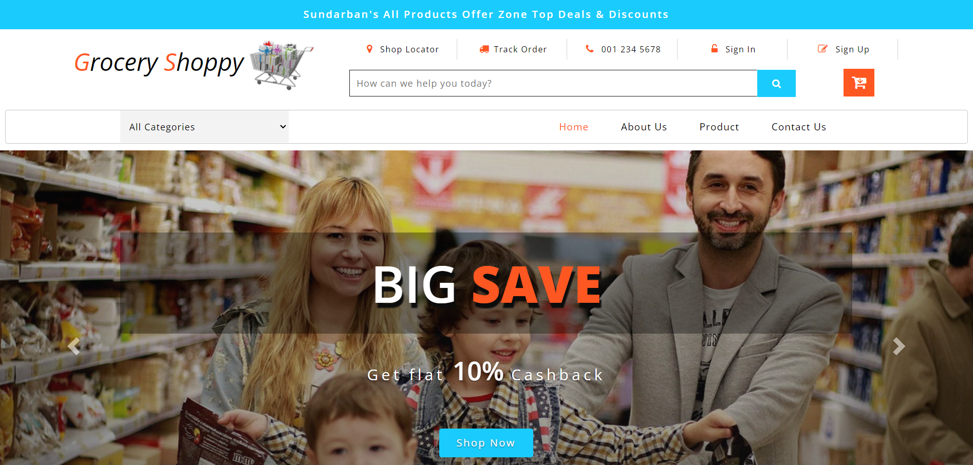 Home page:

About us Page:

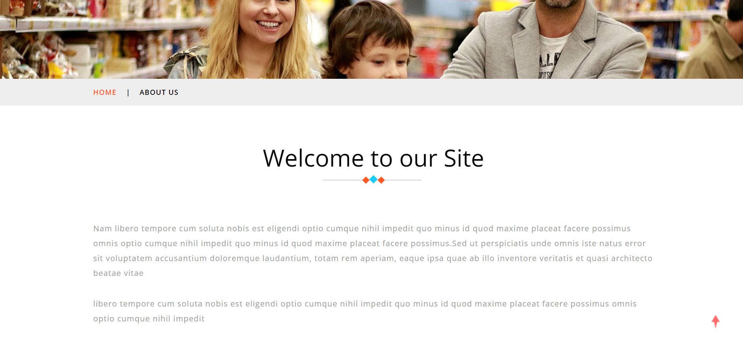

Contact Us Page:

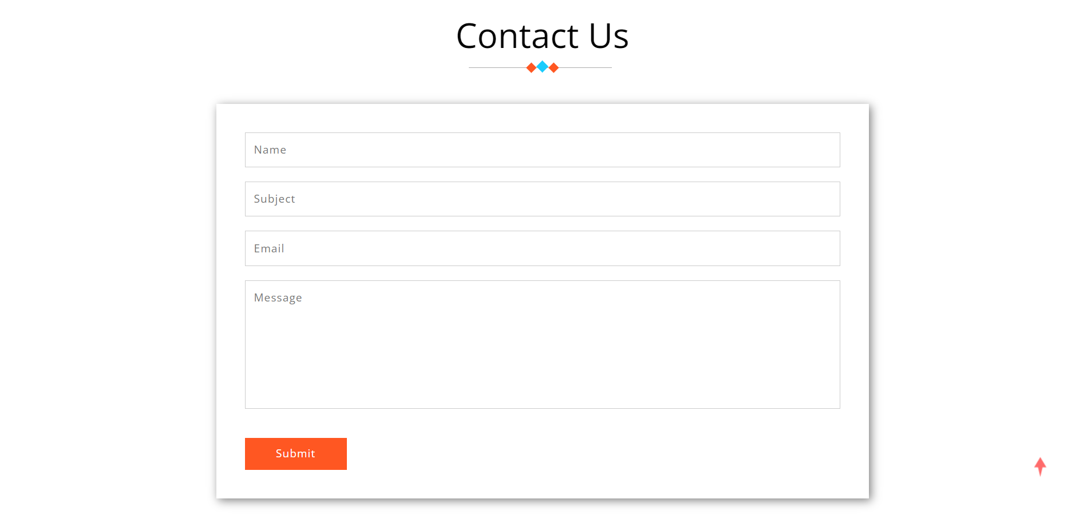

Product Page:-

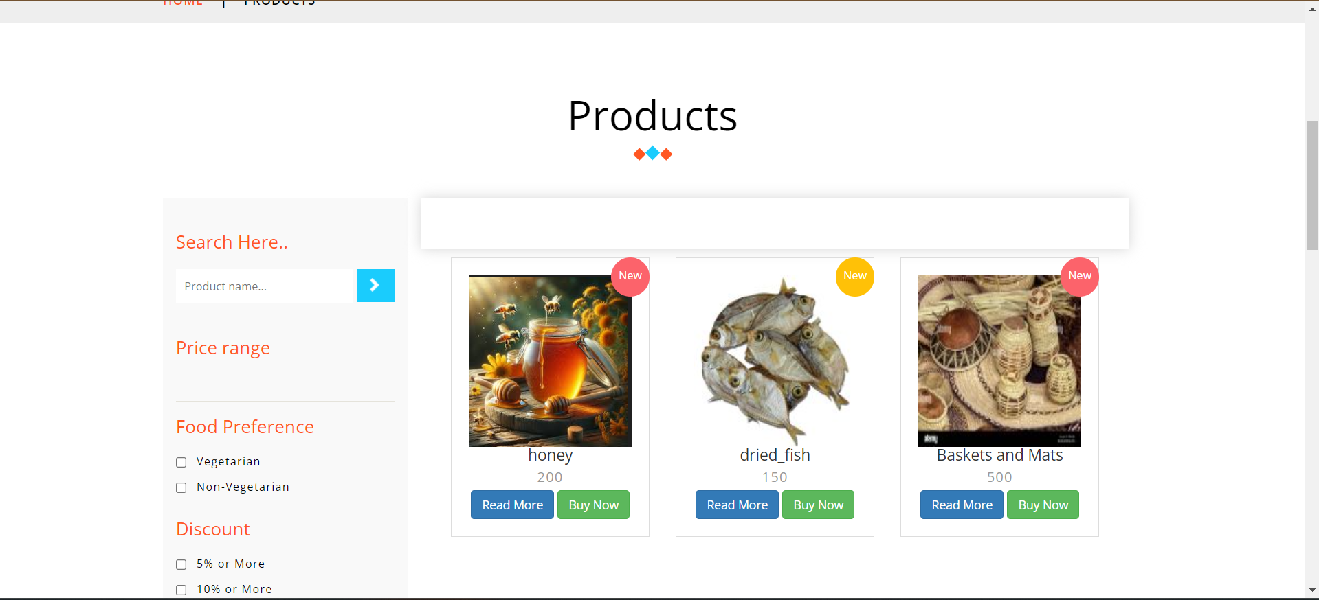

Login Page:-

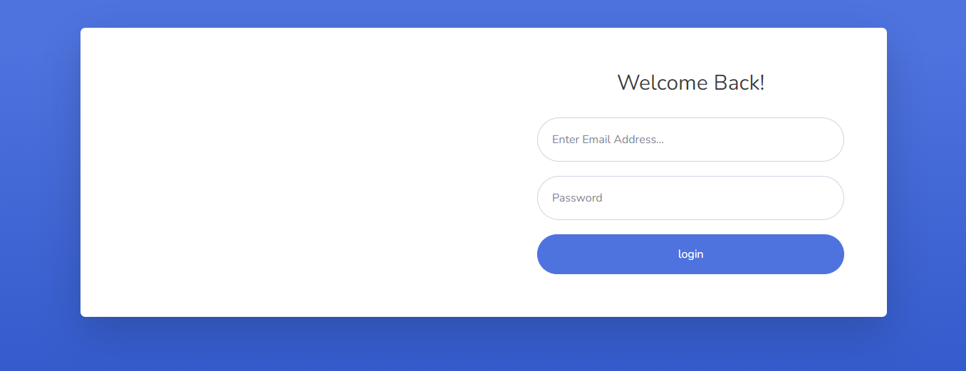

Add Product Page:-

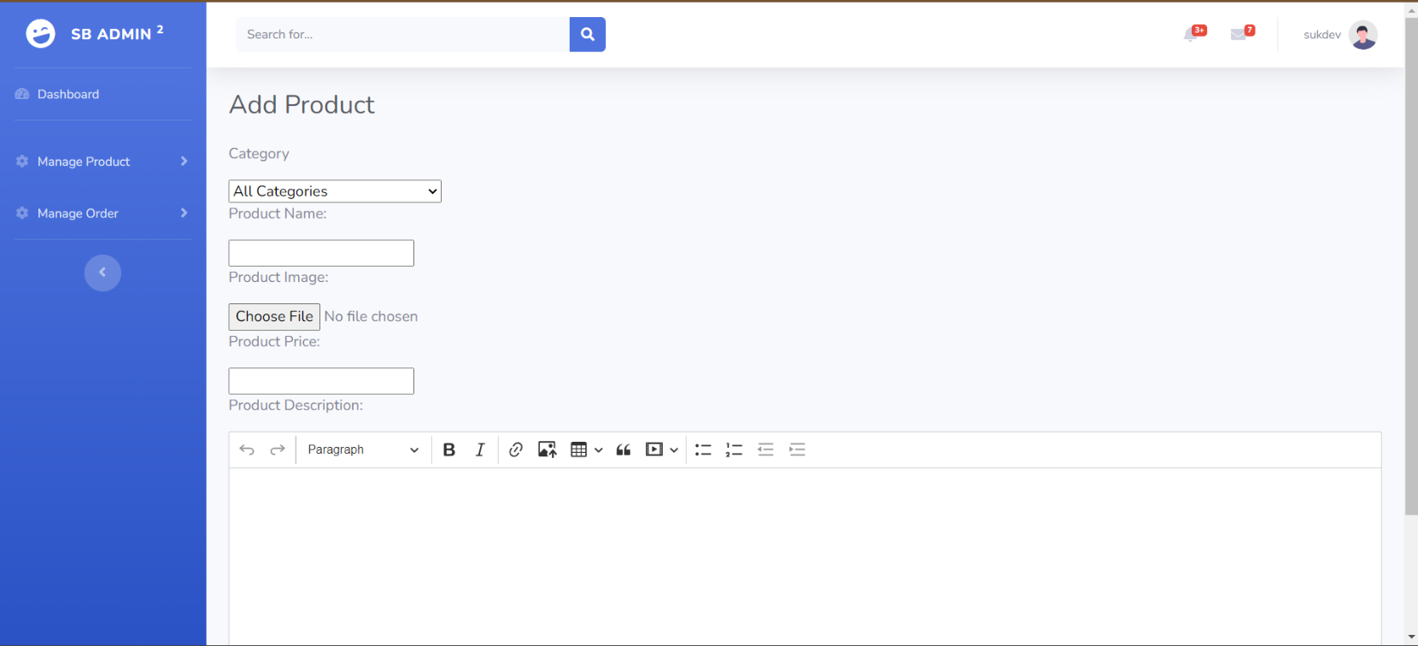

List Product Page:-

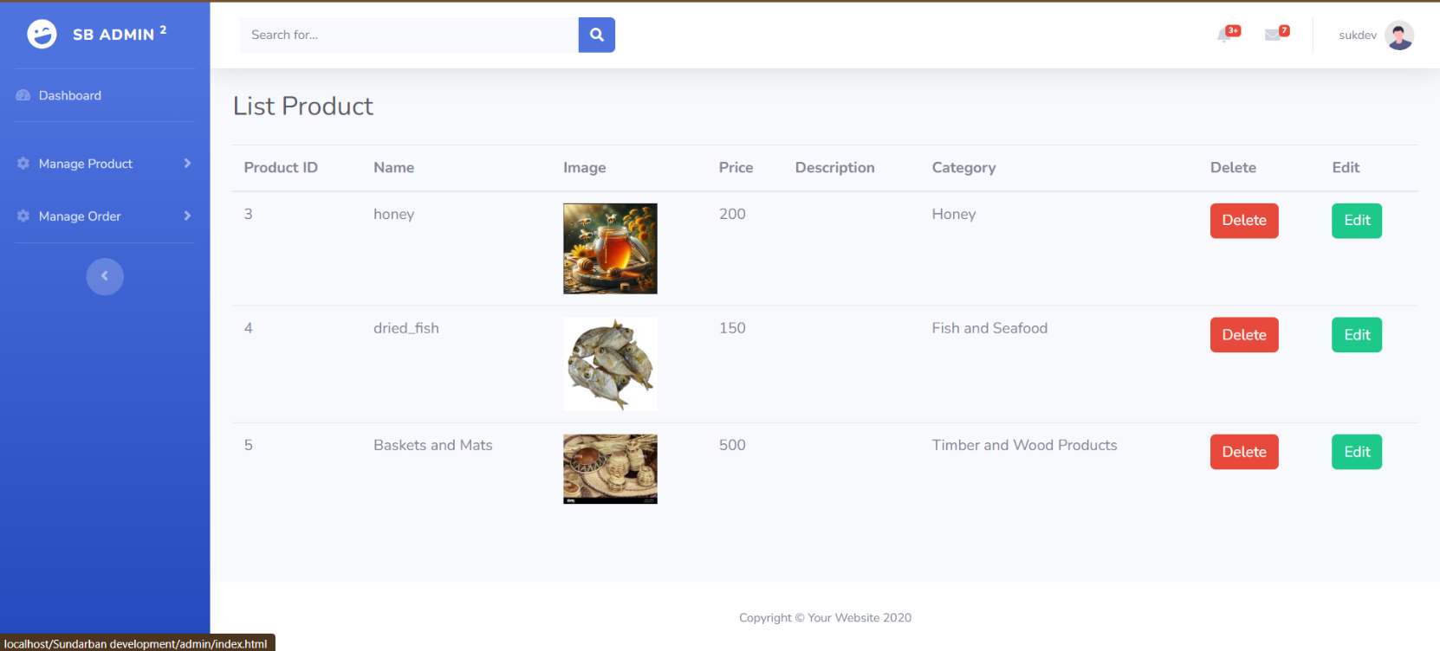

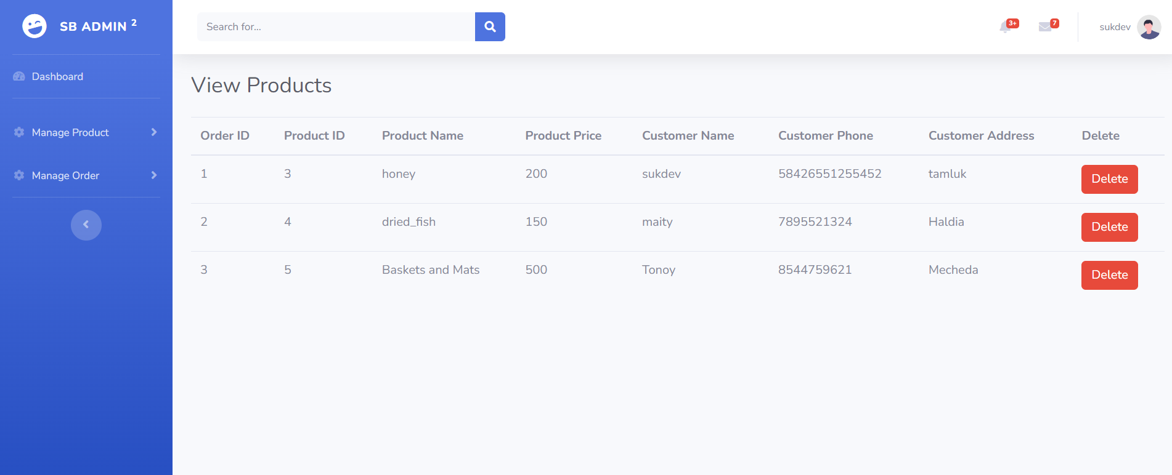 Customer Details Page:-

**Software Testing Techniques:**

The categorization of software testing is a part of diverse testing activities, such as **test strategy, test deliverables, a defined test objective, etc.** And software testing is the execution of the software tofind defects. A strategy for software testing must accommodate low-level test that are necessary to verify that a small source code segment can be correctly implemented as well as high –level tests that validate major system functions against customer requirements.

Types of Testing

1. **Alpha Testing: -**

Testing after code is mostly complete or contains most of the functional and prior to end user being involved. More often this testing will be performed in house or by an outside testing firm in close cooperation with the software engineering department.

1. **Beta Testing: -**

Testing after the product is code complete. Betas are often widely distributed or even distributed to the public at large in hopes that they will buy the final product when it is released.

1. **Functional Testing: -**

Testing two or more modules together with the intent of finding defects, demonstrating that defects are not present, verifying that the modules performs its intended functions as stated in the specification and establishing confidence that a program does what it is supposed do.

1. **Configuration Testing: -**

Testing to determine how well the product works with a broad of the hardware/peripheral equipment configurations as on the different operating systems and software.

1. **Pilot Testing: -**

Testing that involves the users just before actual release to ensure that users become familiar with the release contents and ultimately accept it. Typically involves many users, is conducted over a short period of time and is tightly controlled.

1. **System Integration Testing: -**

Testing a specific hardware/software installation. This is typically performed on a COTS system or any other system comprised or the disparate parts where custom configurations and /or unique installation are the norm .

1. **Software Testing: -**

The process of exercising software is with the intent of ensuring that the software system meets its requirements and the user expectations and doesn’t file in an unacceptable manner .

1. **Security testing: -**

Testing of database and network software in order to keep company data and resources from mistaken/ accidental users, hackers and other malevolent attackers.

1. **Installation Testing: -**

Testing with the intent of determining if the product will install on a variety of platforms and how easily it installs .

1. **Compatibility Testing: -**

Testing used to determine whether other system software components such as browsers, utilities and competing software would conflict with the software being tested.

**Maintenance**

The maintenance of existing software can account for over 60 percent of all effort expended by development organisation and the percentage continues to rise as more software is produced. There are four different kinds of maintenance:

1. **Corrective maintenance**: Corrective maintenance changes the software to correct defects.
2. **Adaptive maintenance:** Adaptive maintenance results in modifications to the software to accommodate changes to its external environment.
3. **Perfective maintenance:** Perfective maintenance extends the software beyond its original functional requirements.
4. **Preventive maintenance:** Preventive maintenance often called software reengineering must be conducted to enable software to serve the needs of its end users. In essence preventive maintenance makes changes to computer programs so that they can be more easily corrected, adopted and enhanced.

The following software is designed into modules (having well defined inputs, outputs and non-overlapping specific usage) – which makes it easier to maintain. Suppose a correction or perfection to the code is made due to user requirement; the effect remains within the particular module; the rest of the software remain intact.

**Future Scope of system**

* + Like I mentioned earlier, full integration of open source tools is critical in creating a seamless overall application. There are some ways in which Web Calendar was not integrated which I would like to pursue given more time.
  + The main feature is an online payment which will be applicable and implemented in the future.
* Integrating payment gateway to the parlour site ensures secure payment processing, easy payment checkouts, and generates more sales.
  + We will try to provide more beauty parlour Services so that user gets what they need. This system will try and be able to add new more feature. We will try to provide a more user-friendly interface in the future.

**Conclusion**

The development of the Sundarbans, a unique and ecologically sensitive region straddling India and Bangladesh, presents both opportunities and challenges. As a UNESCO World Heritage site and the largest mangrove forest in the world, the Sundarbans is home to diverse flora and fauna, including the endangered Royal Bengal Tiger. Its development must balance environmental conservation with socio-economic growth for the millions of people living in and around the area.

Developing the Sundarbans should be guided by a model that integrates environmental sustainability, economic development, and social equity. This unique region requires a careful and balanced approach that respects its ecological significance while enhancing the quality of life for its inhabitants. With collaborative efforts from governments, NGOs, and local communities, the Sundarbans can serve as a global example of sustainable development in sensitive ecosystems.

**BIBLIOGRAPHY**

For successfully completing my Project , I have taken help from some websites and books. During the development of the assignment I have use the following books and websites links.

References:

1. startbootstrap.com
2. www.w3schools.com
3. getbootstrap.com
4. www.tutorialspoint.com